### **CI/CD Deployment Assignment**

You are required to deploy a **Flask backend** and an **Express frontend** on an **Amazon EC2 instance**. Additionally, implement a **CI/CD pipeline** using Jenkins to automate the deployment process.

#### **Part 1: Deploy Flask and Express on a Single EC2 Instance**

1. **Objective**:
   * Deploy both the Flask backend and the Express frontend on a **single Amazon EC2 instance**.
2. **Steps**:
   * **Provisioning the EC2 Instance**:
     + Launch an EC2 instance on AWS (you can use a free-tier eligible instance).
     + SSH into the instance and install the following dependencies:
       - Python for Flask.
       - Node.js for Express.
       - Git for pulling the application code.
   * **Application Setup**:
     + Clone the Flask and Express repositories onto the EC2 instance.
     + Install the required dependencies for both applications using pip and npm.
     + Configure both applications to run on different ports (e.g., Flask on port 5000 and Express on port 3000).
     + Start the applications using process managers like pm2 or systemd to ensure they remain active.
3. **Deliverables**:
   * A running EC2 instance with Flask and Express accessible via the instance's public IP.
   * A description or diagram of the deployed architecture.

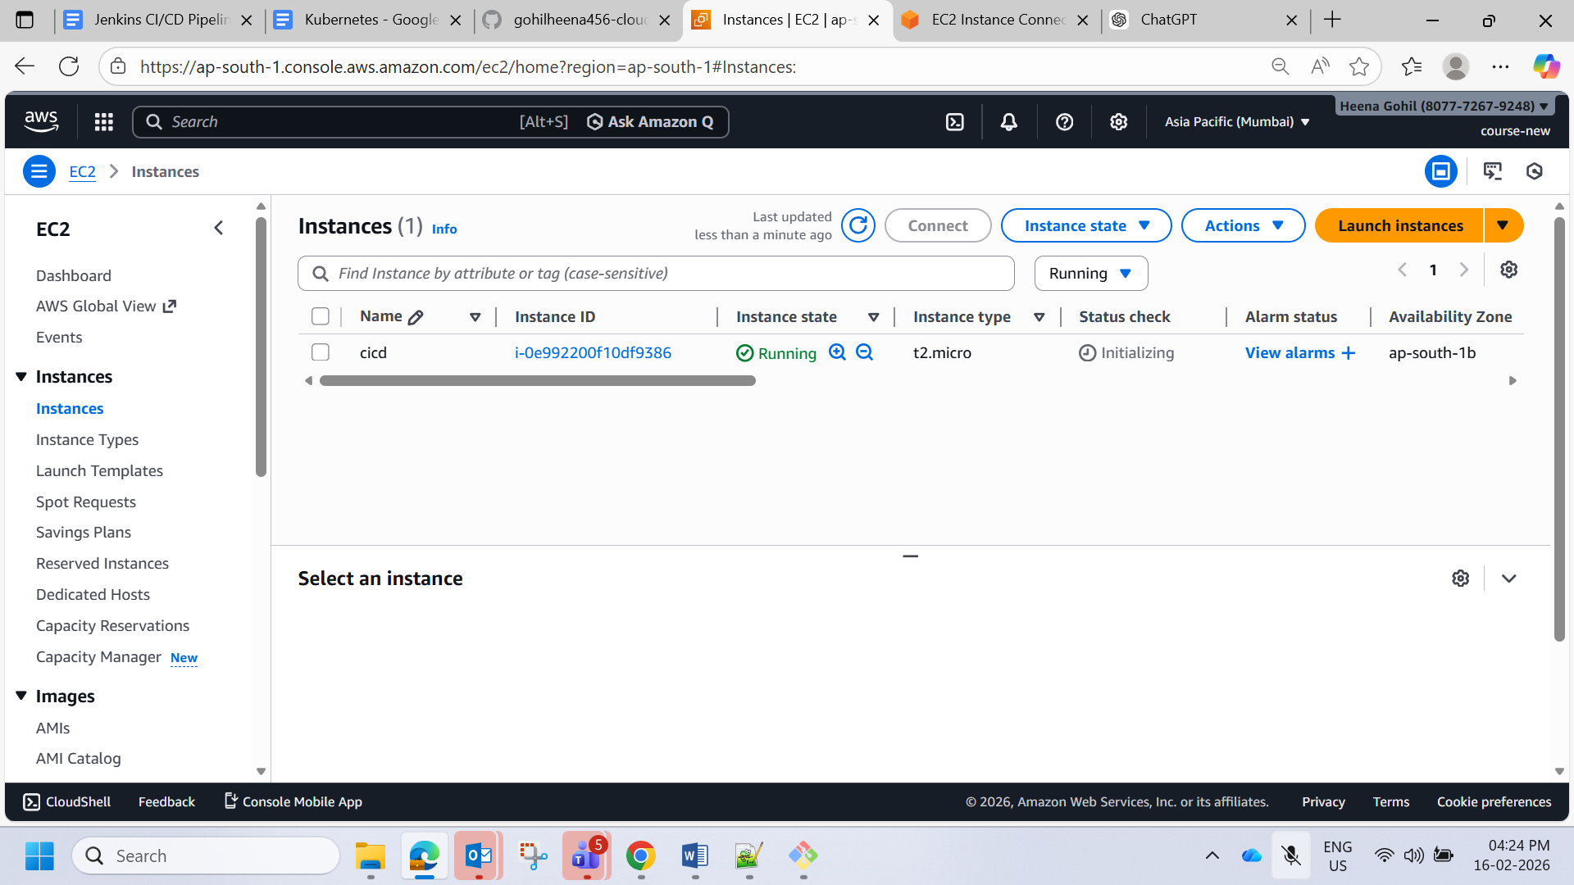

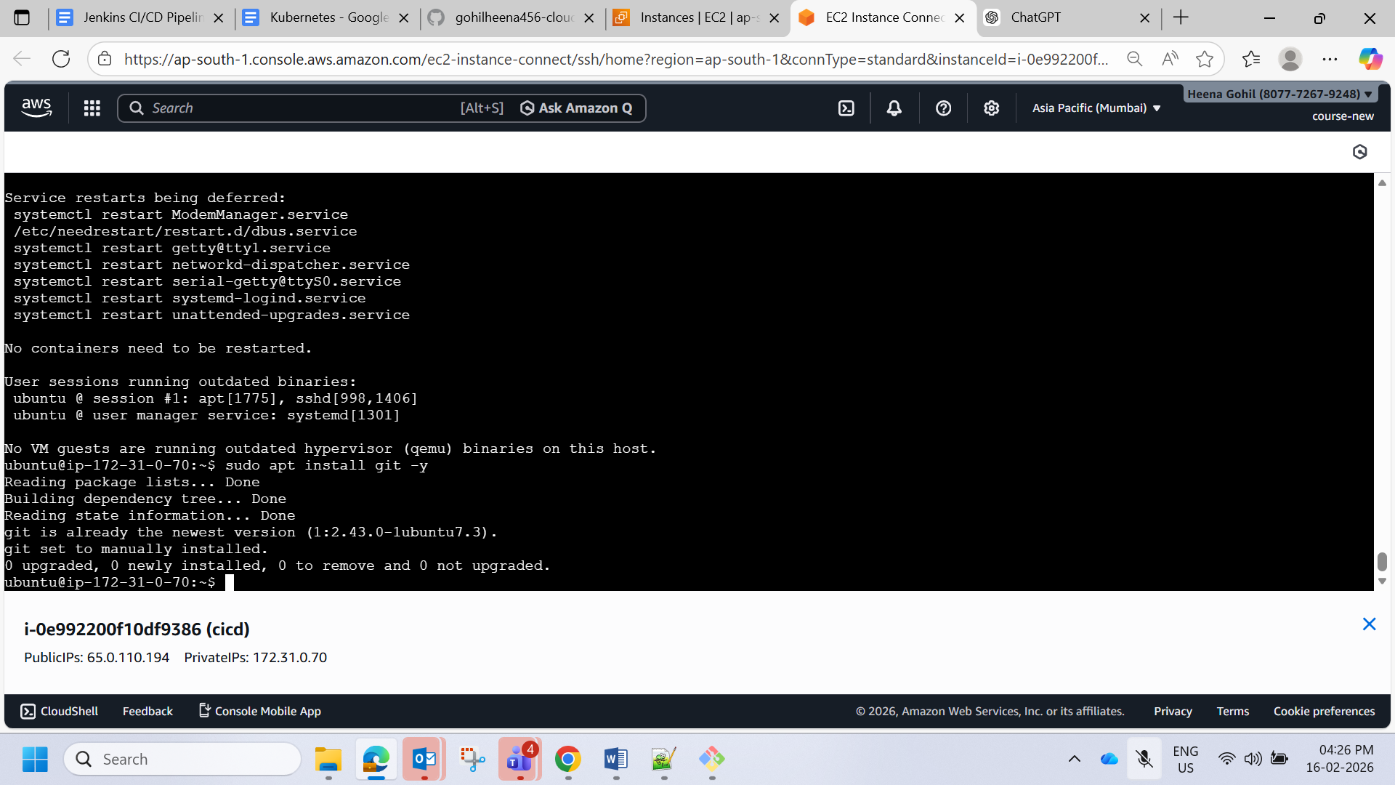

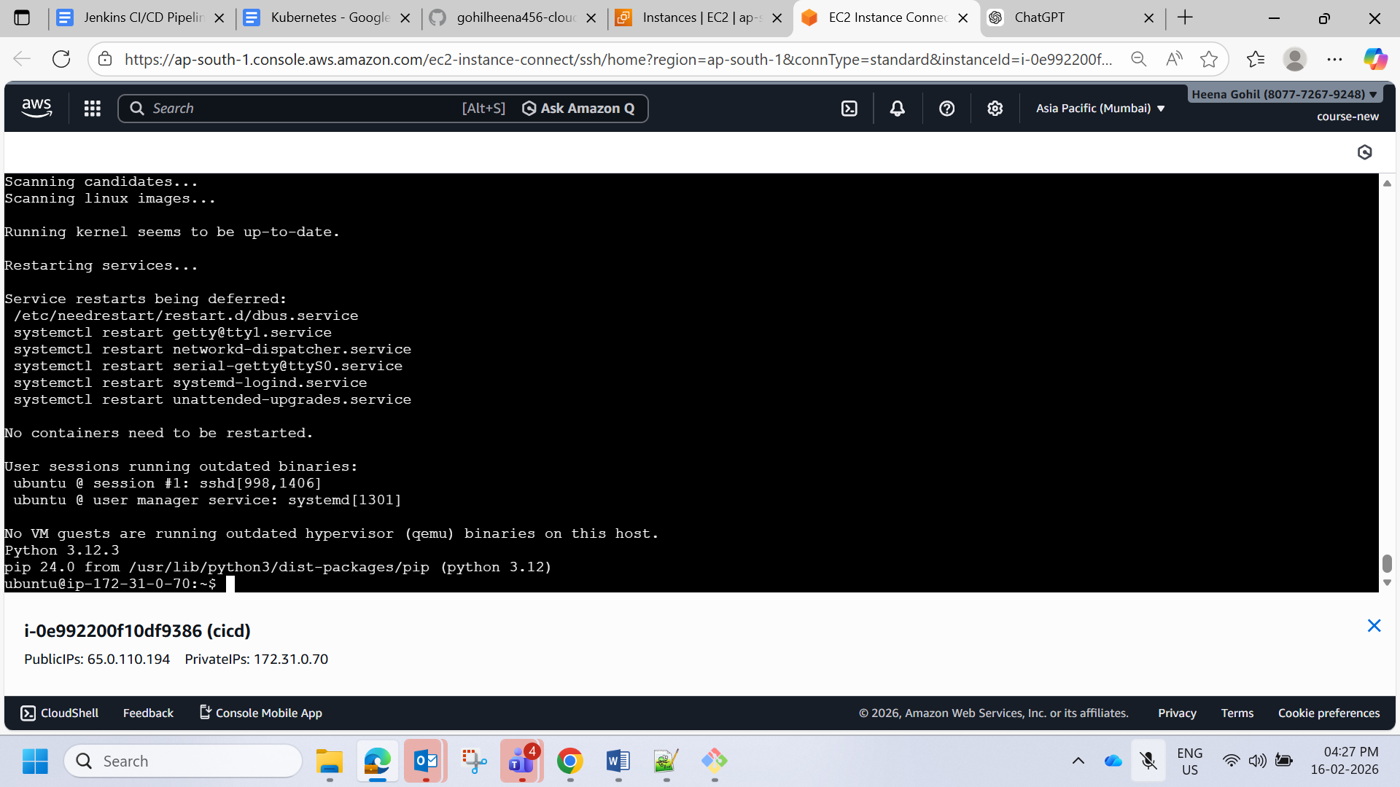

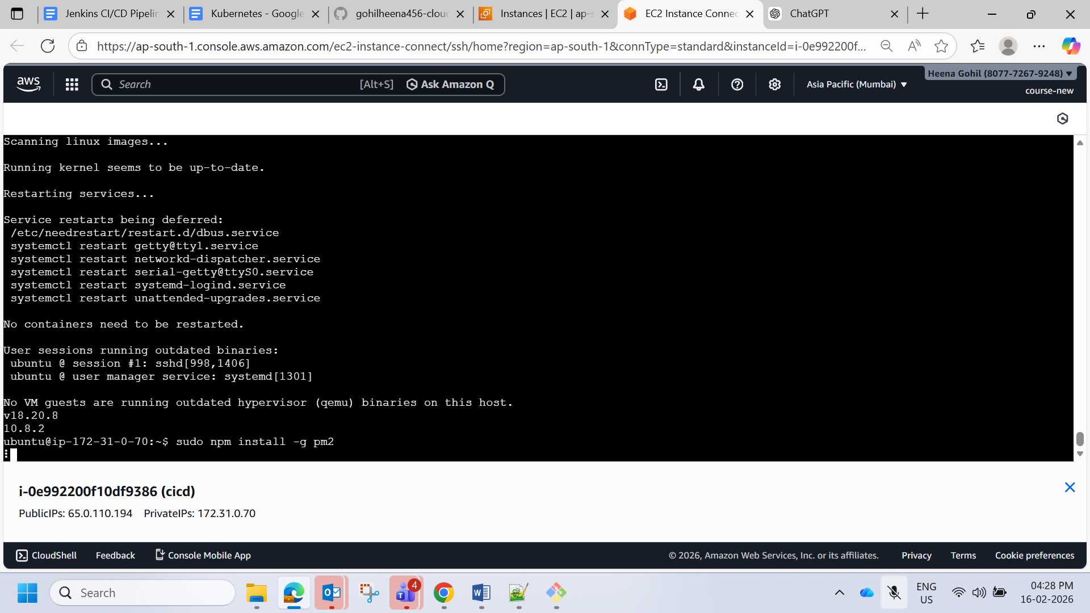

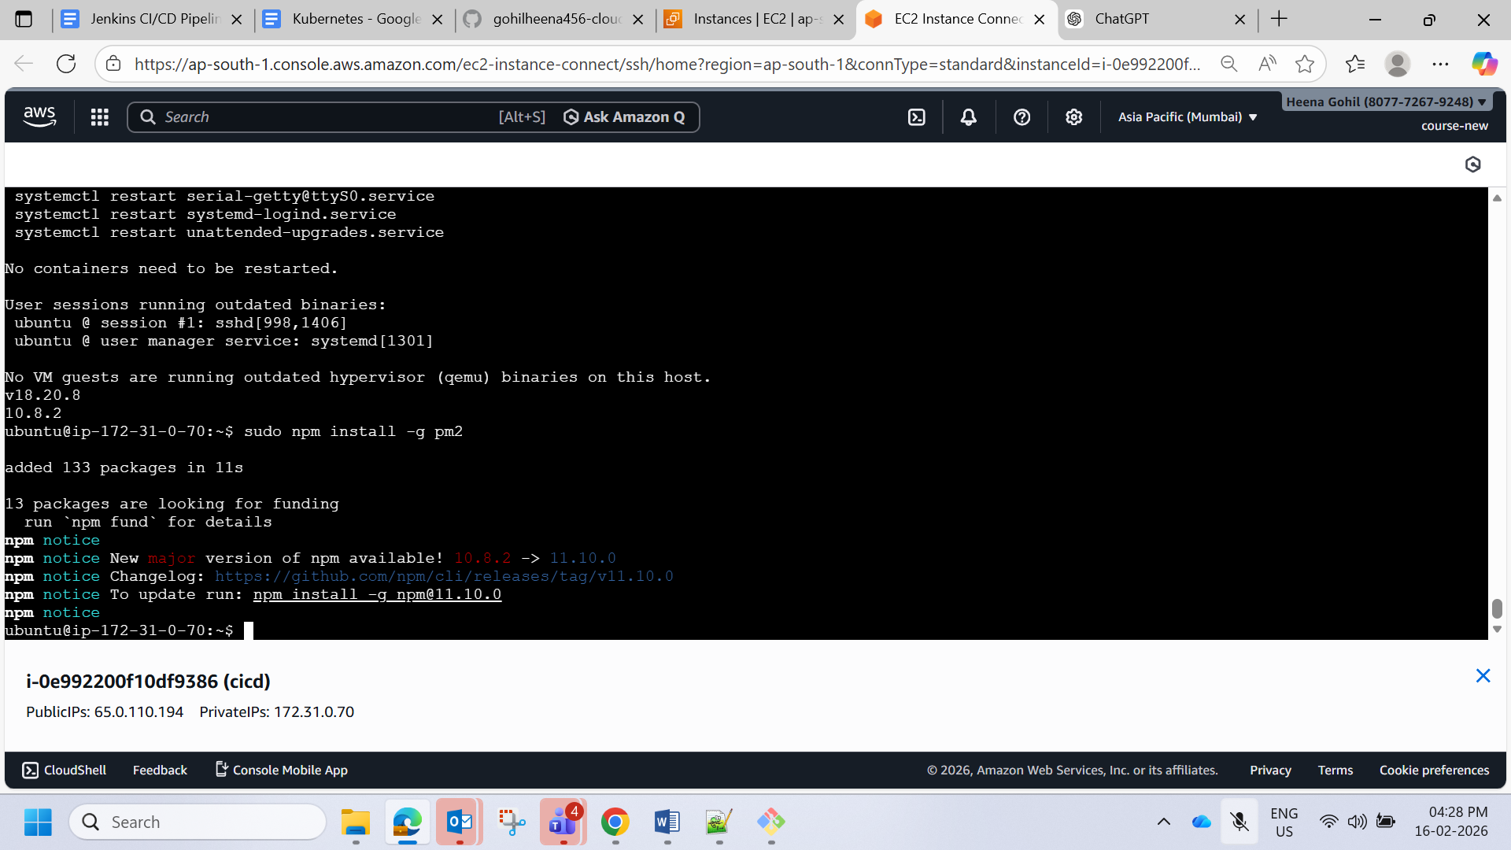

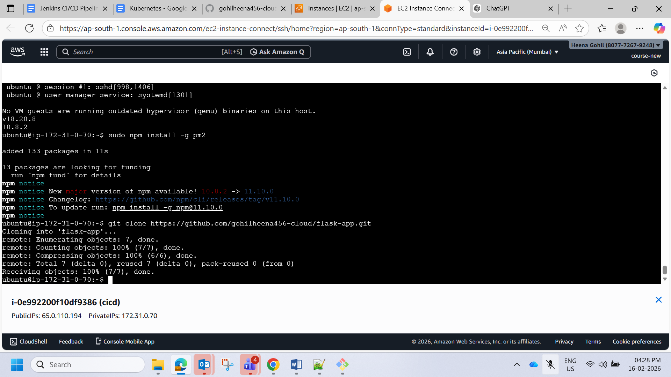

[gohilheena456-cloud/flask-app](https://github.com/gohilheena456-cloud/flask-app)

<https://github.com/gohilheena456-cloud/flask-app>

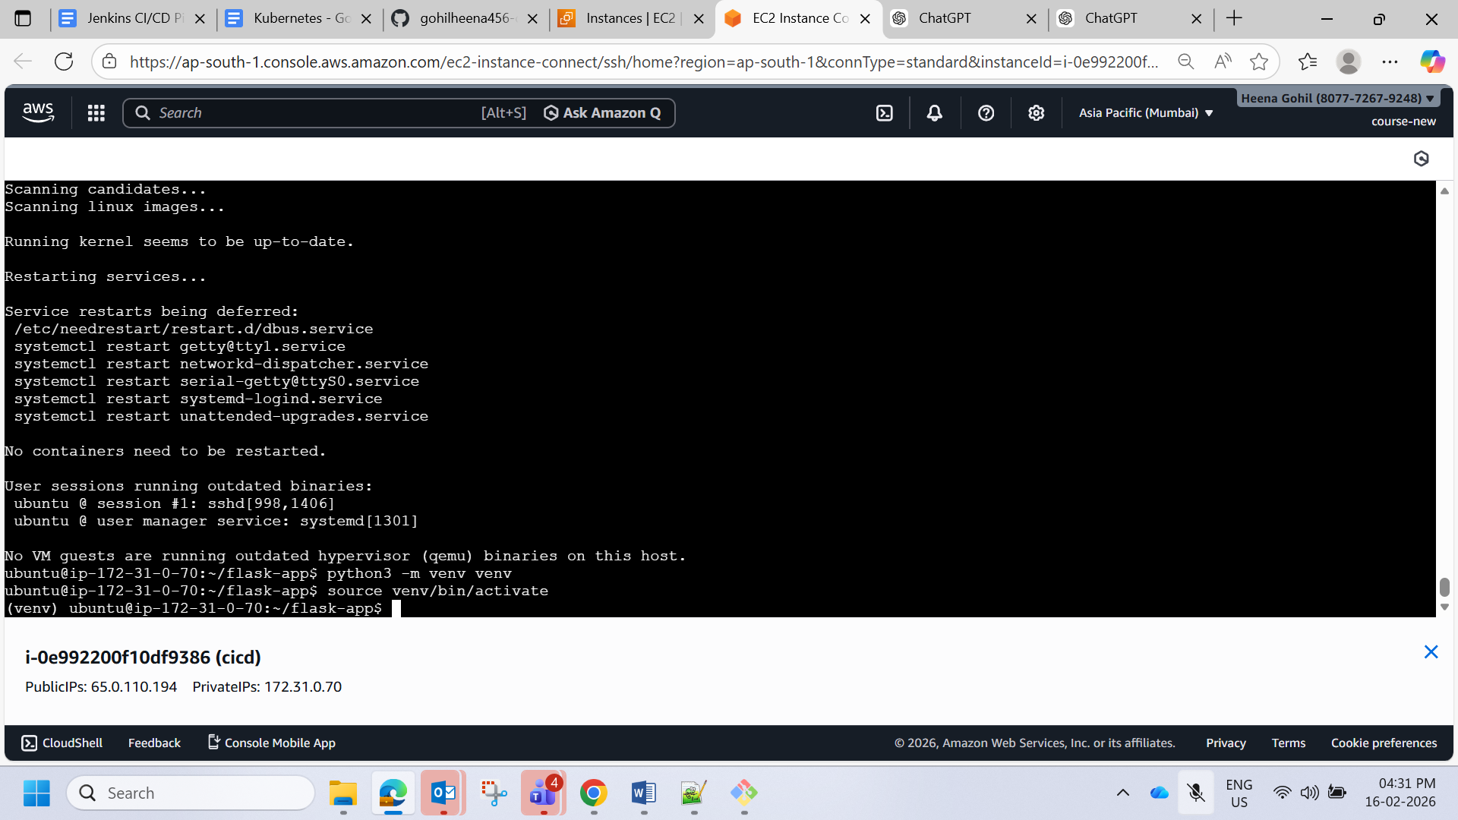

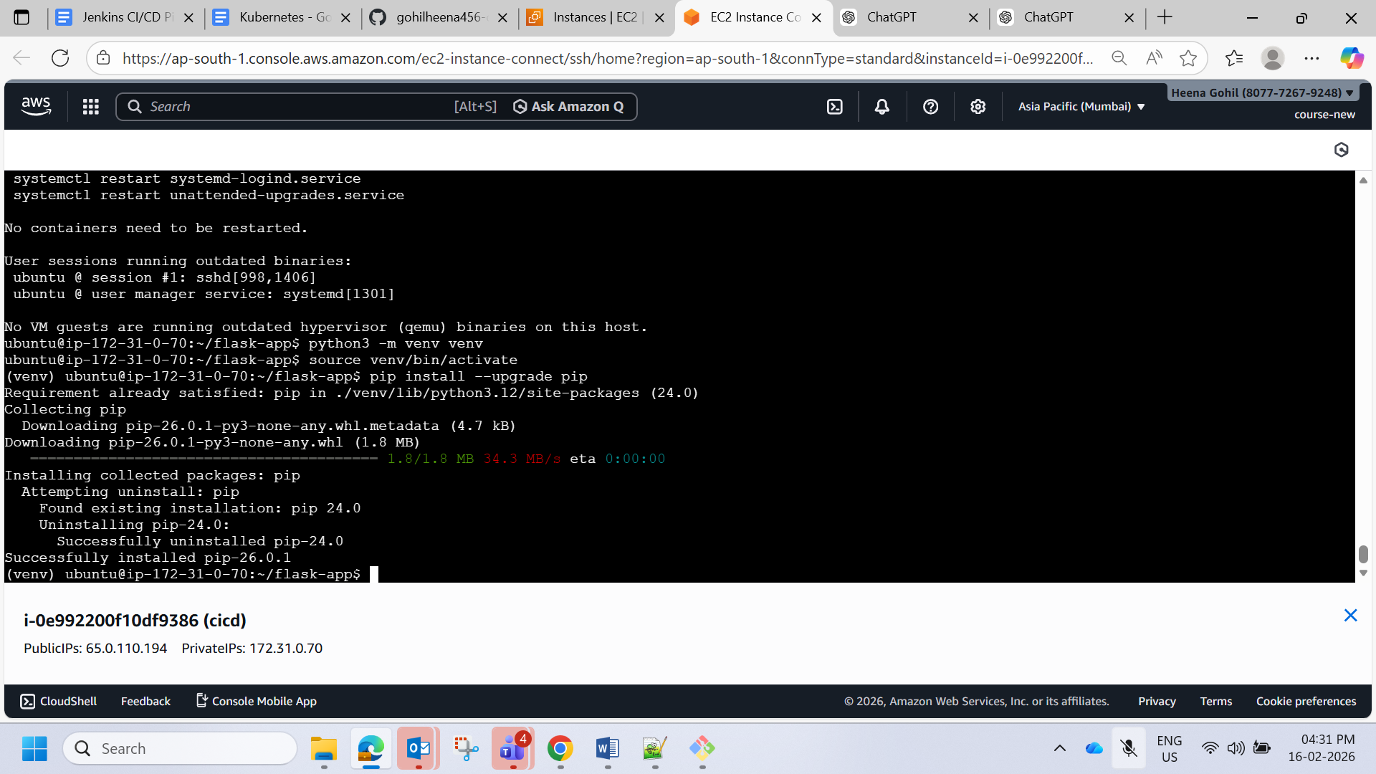

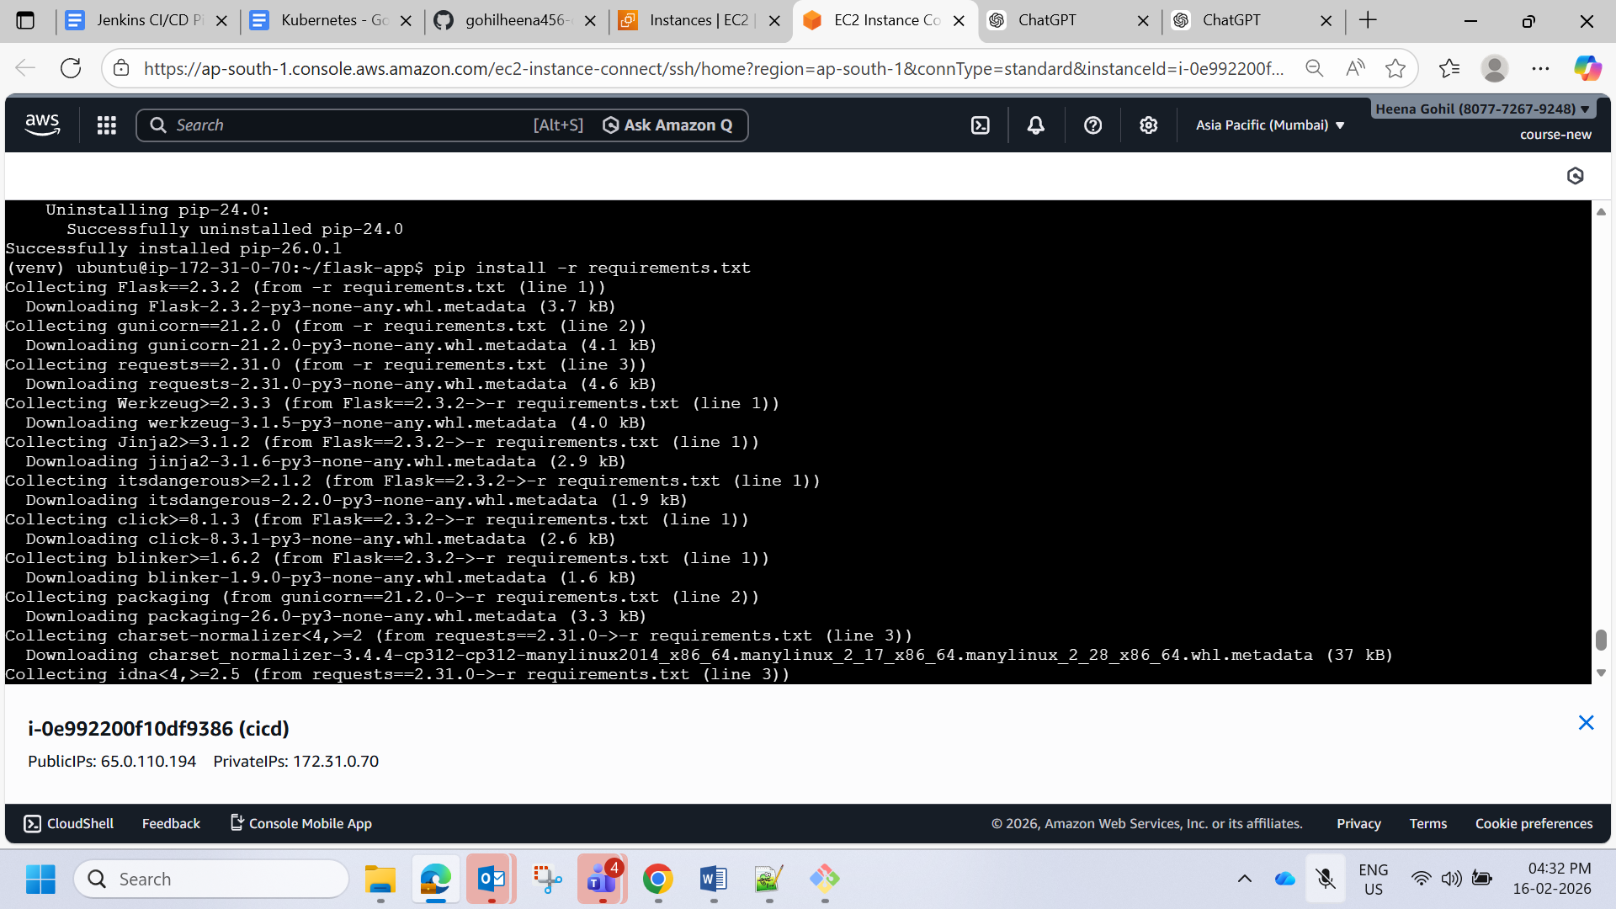

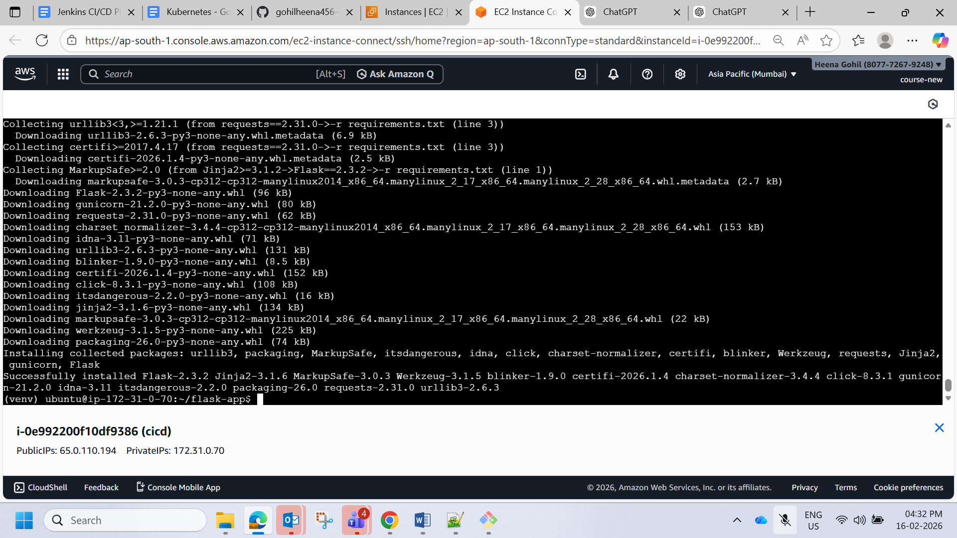

Express

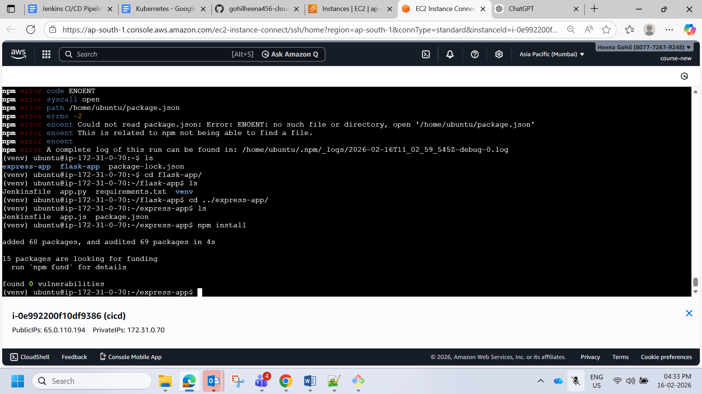

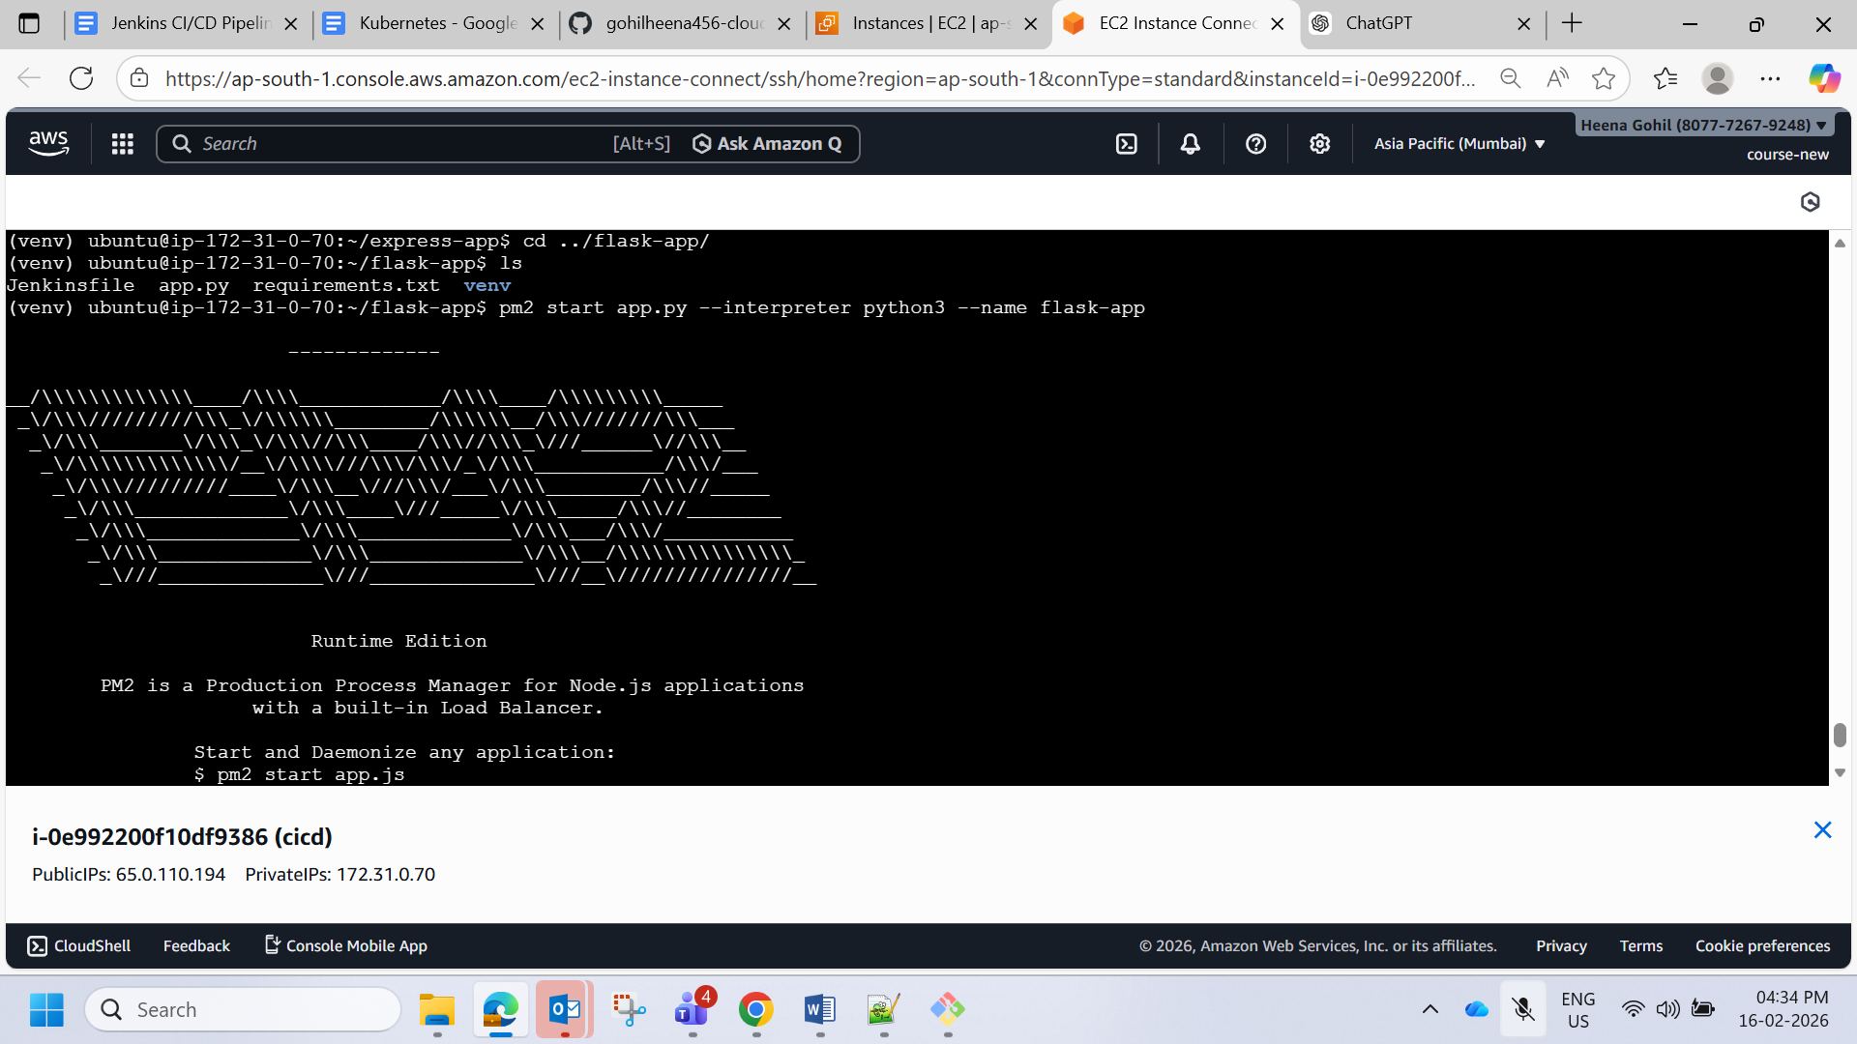

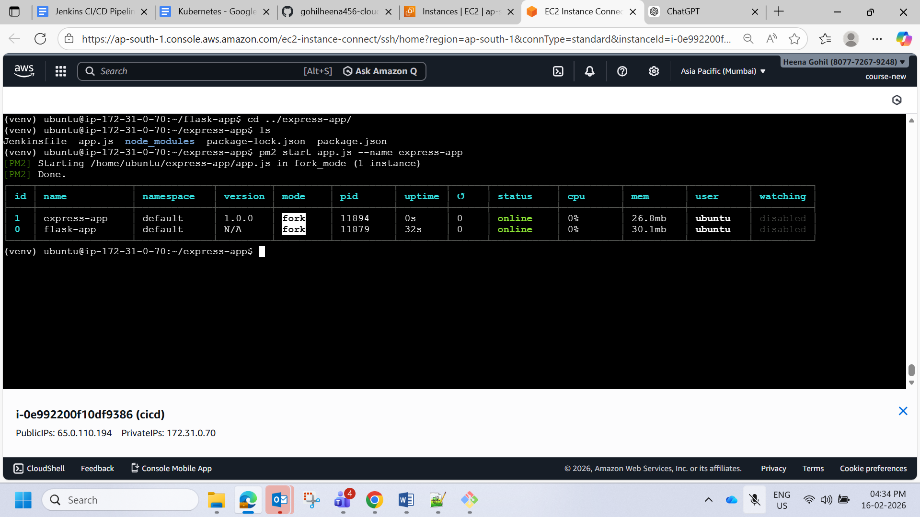

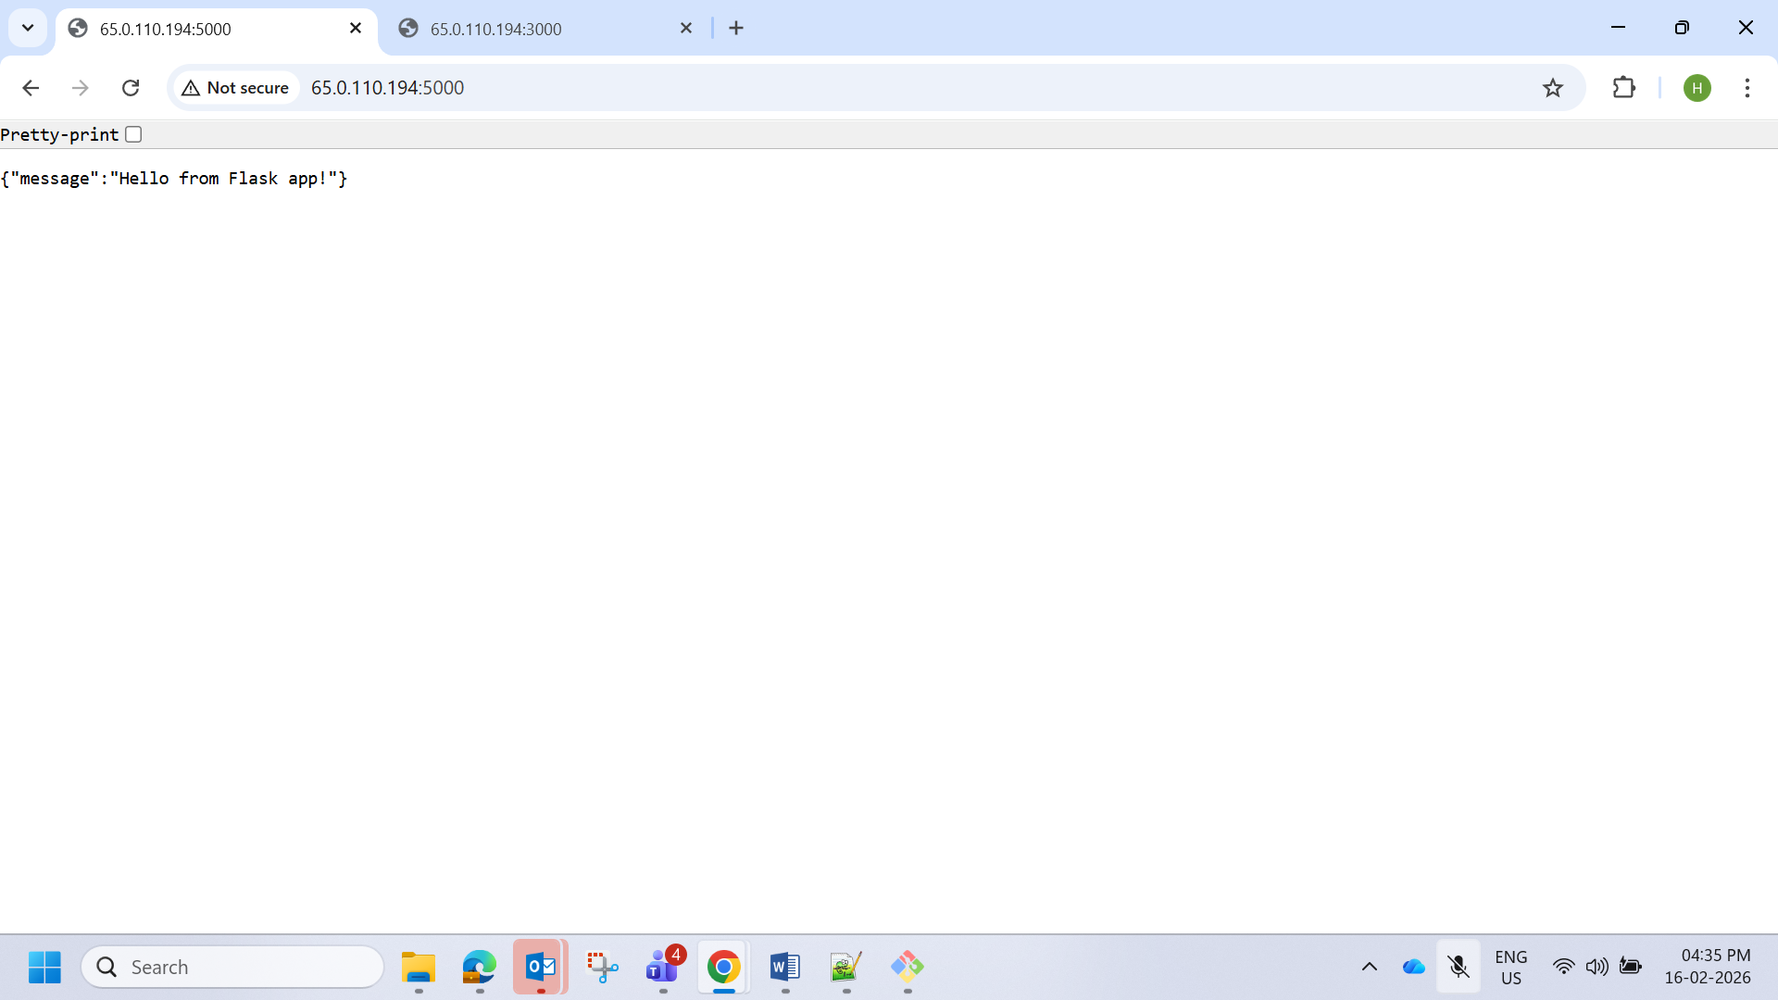

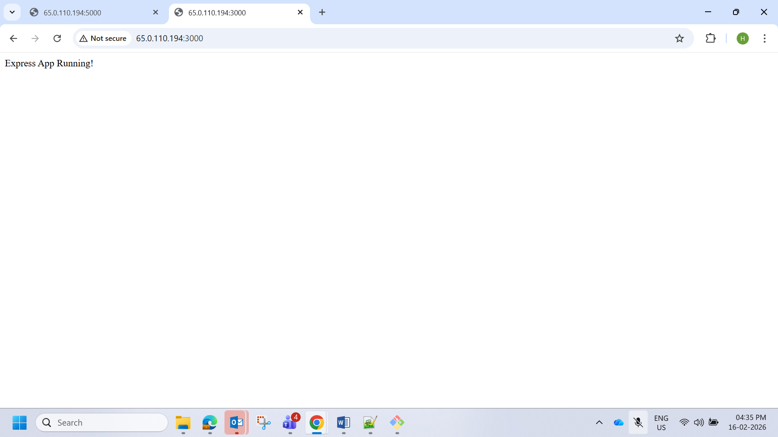

https://github.com/gohilheena456-cloud/flask-app

<https://github.com/gohilheena456-cloud/express-app.git>

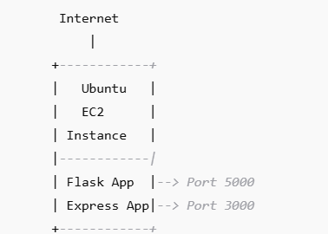

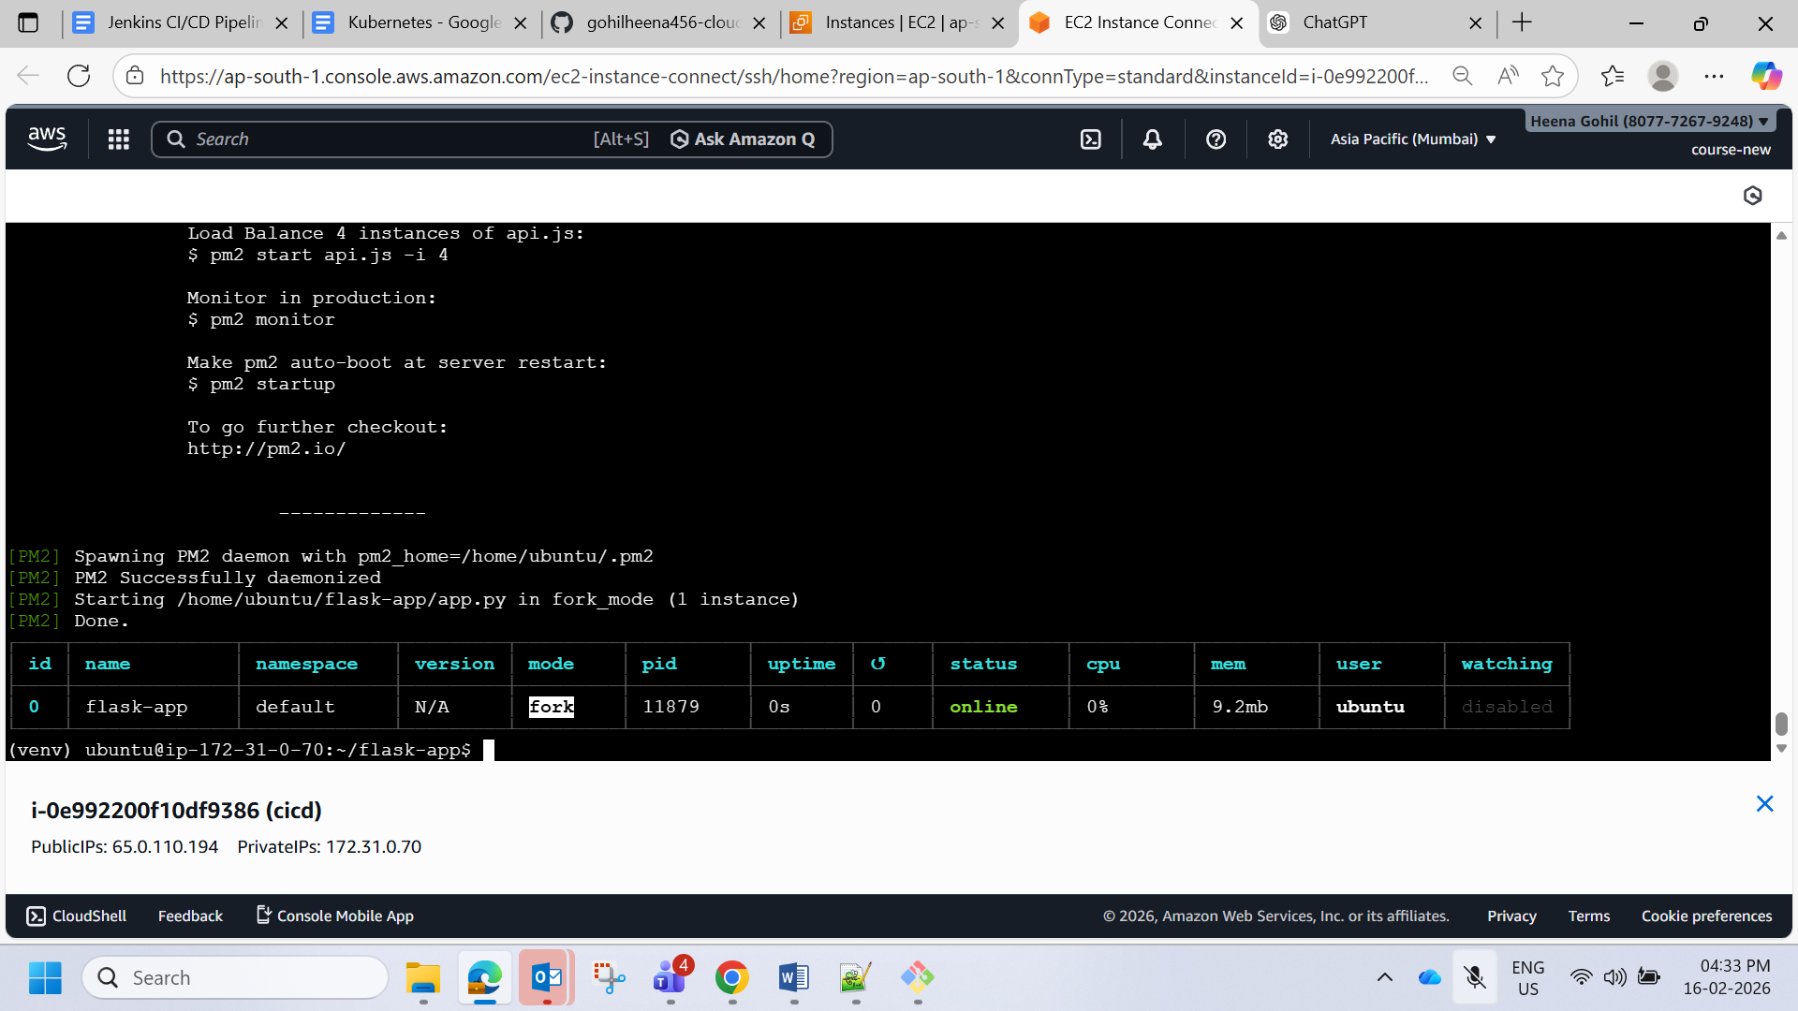

#### **Part 2: Implement CI/CD Pipeline Using Jenkins**

1. **Objective**:
   * Automate the deployment of Flask and Express applications using Jenkins.
2. **Steps**:
   * **Install Jenkins**:
     + Install Jenkins on the same EC2 instance or on a separate machine.
     + Configure Jenkins by installing essential plugins like Git, NodeJS, and Python.
   * **Set Up Jenkins Pipeline**:
     + Create two separate Jenkins pipelines for the Flask and Express applications.
     + **Pipeline Steps**:
       - Pull the latest code from the respective Git repositories.
       - Install dependencies for Flask (pip install -r requirements.txt) and Express (npm install).
       - Restart the applications using the process manager (e.g., pm2 restart <app>).
   * **Triggering the Pipeline**:
     + Set up a GitHub webhook to trigger the Jenkins pipeline on every push to the repositories.
   * **Optional Enhancements**:
     + Add testing stages to the pipeline for both applications.
     + Configure environment variables in Jenkins for managing sensitive data like API keys.
3. **Deliverables**:
   * A fully functional CI/CD pipeline that automates the deployment process for Flask and Express.
   * A Jenkins pipeline script (Jenkinsfile) for each application.
   * Evidence of the pipeline working (e.g., screenshots of successful builds and deployments).

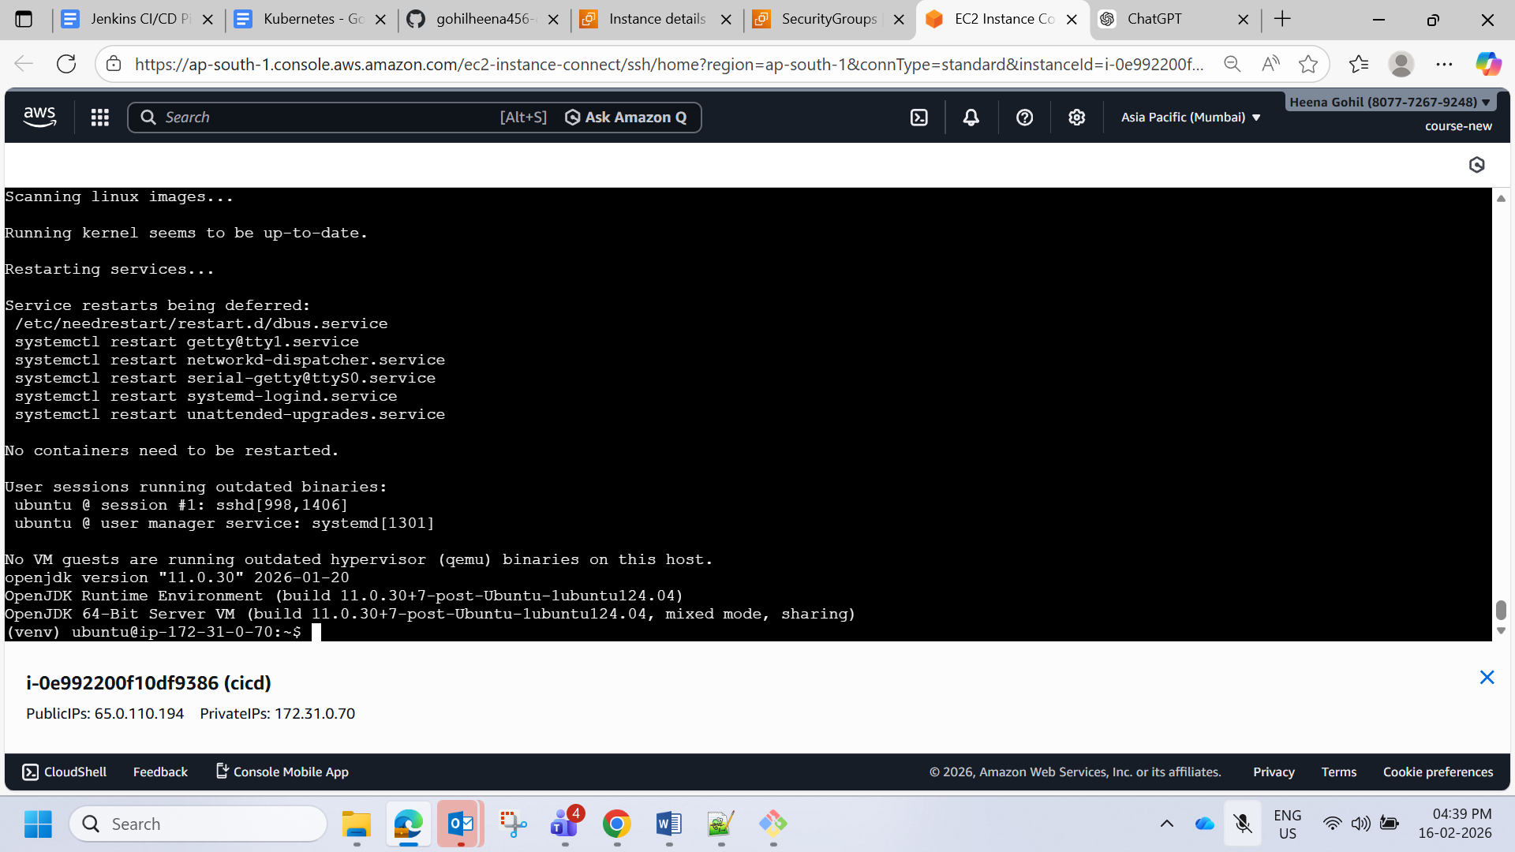

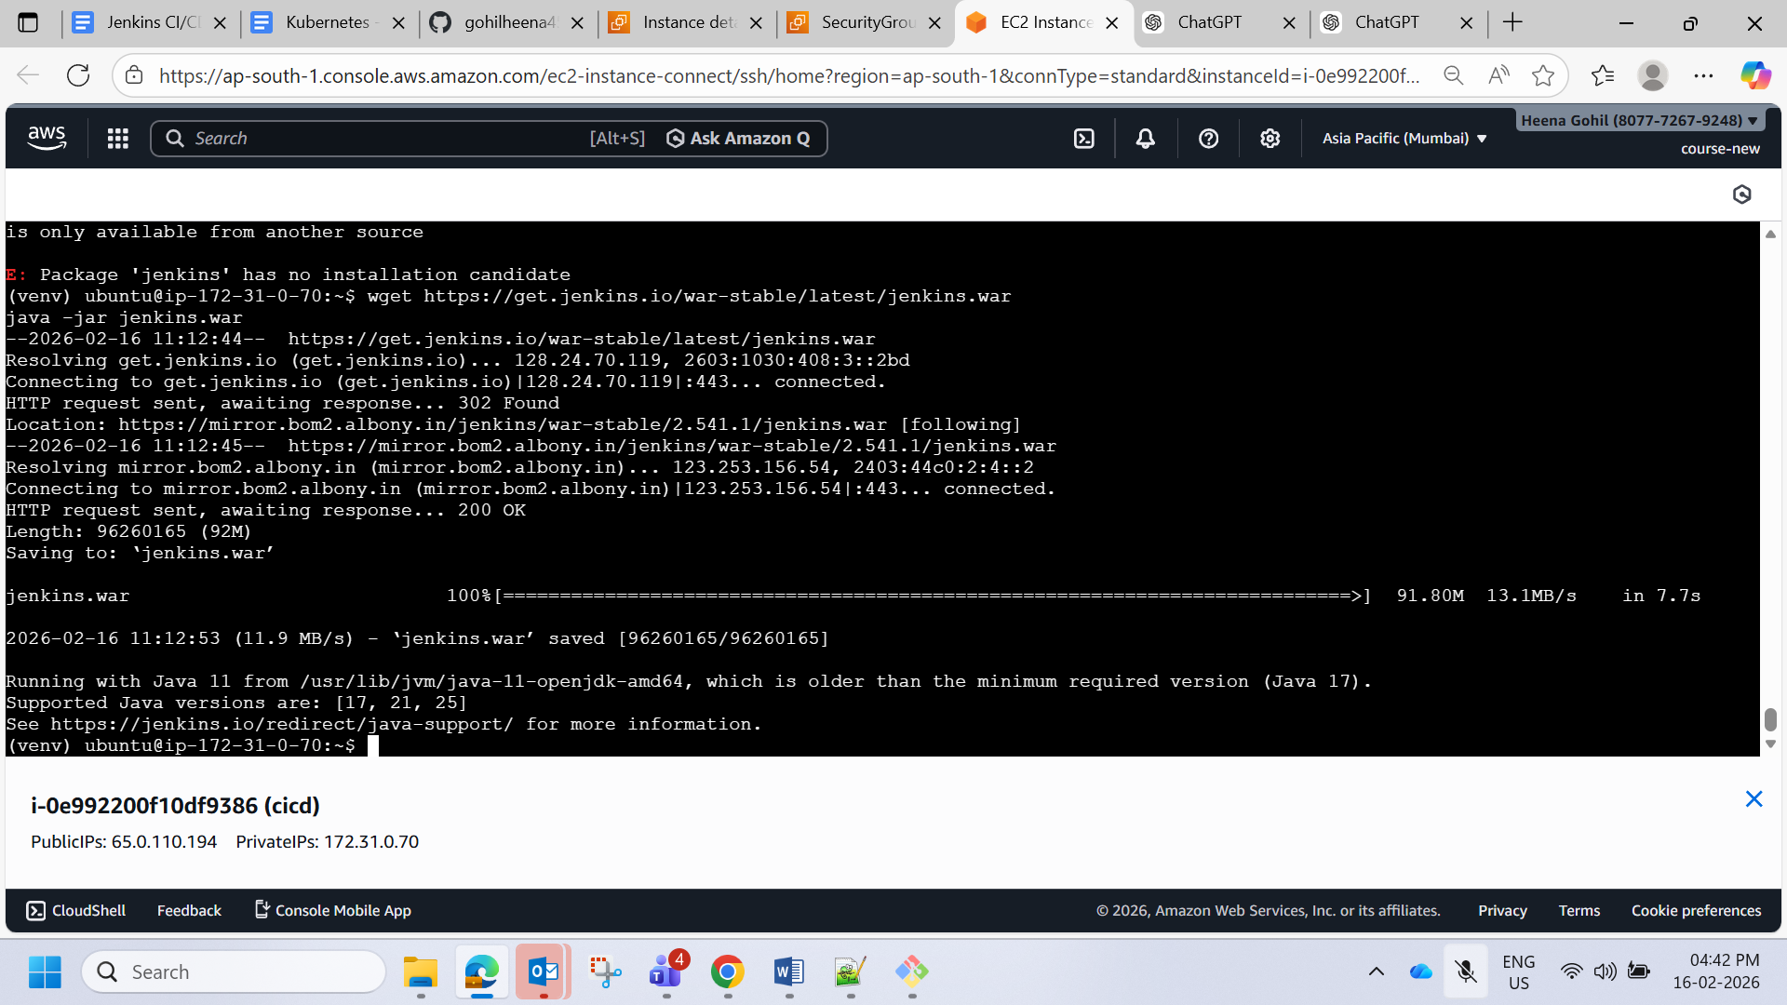

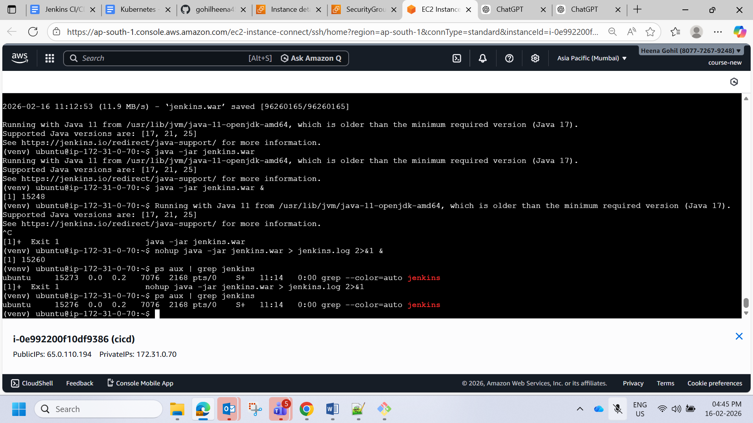

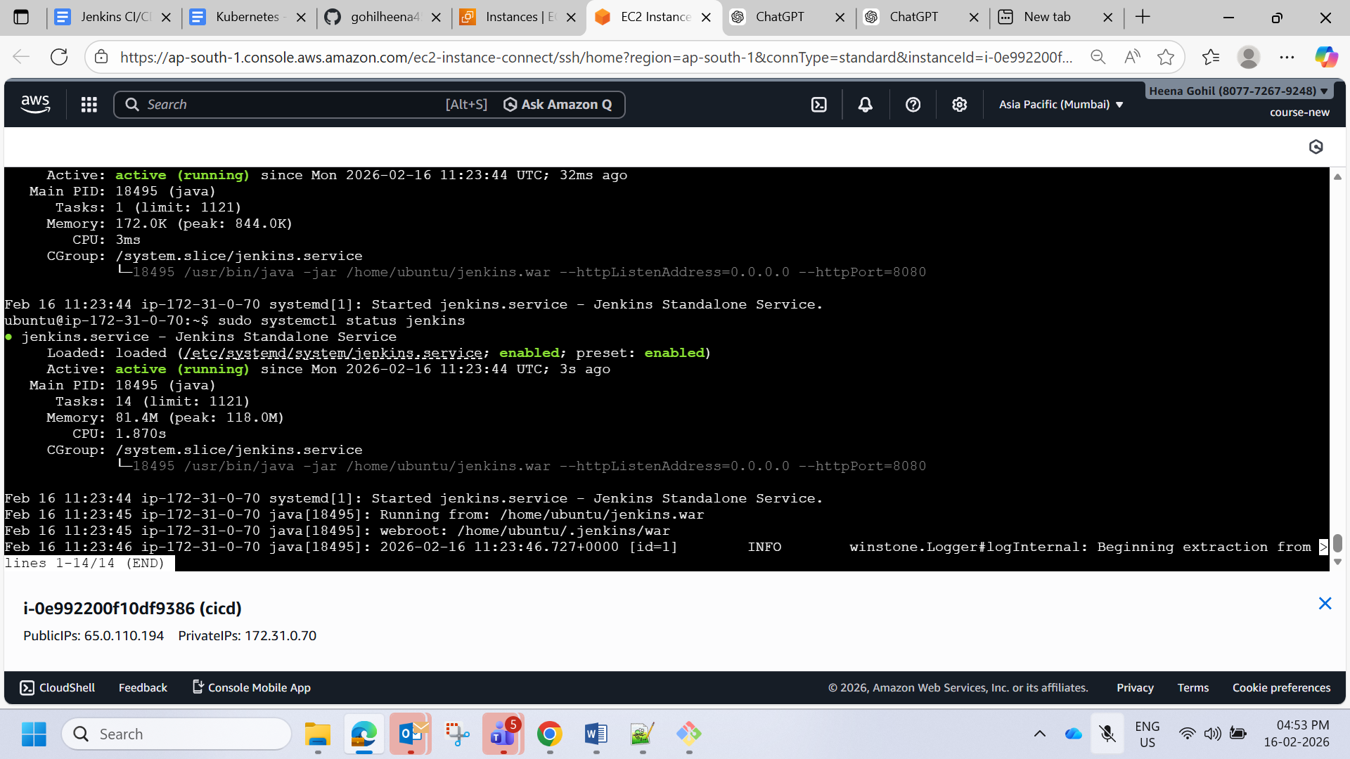

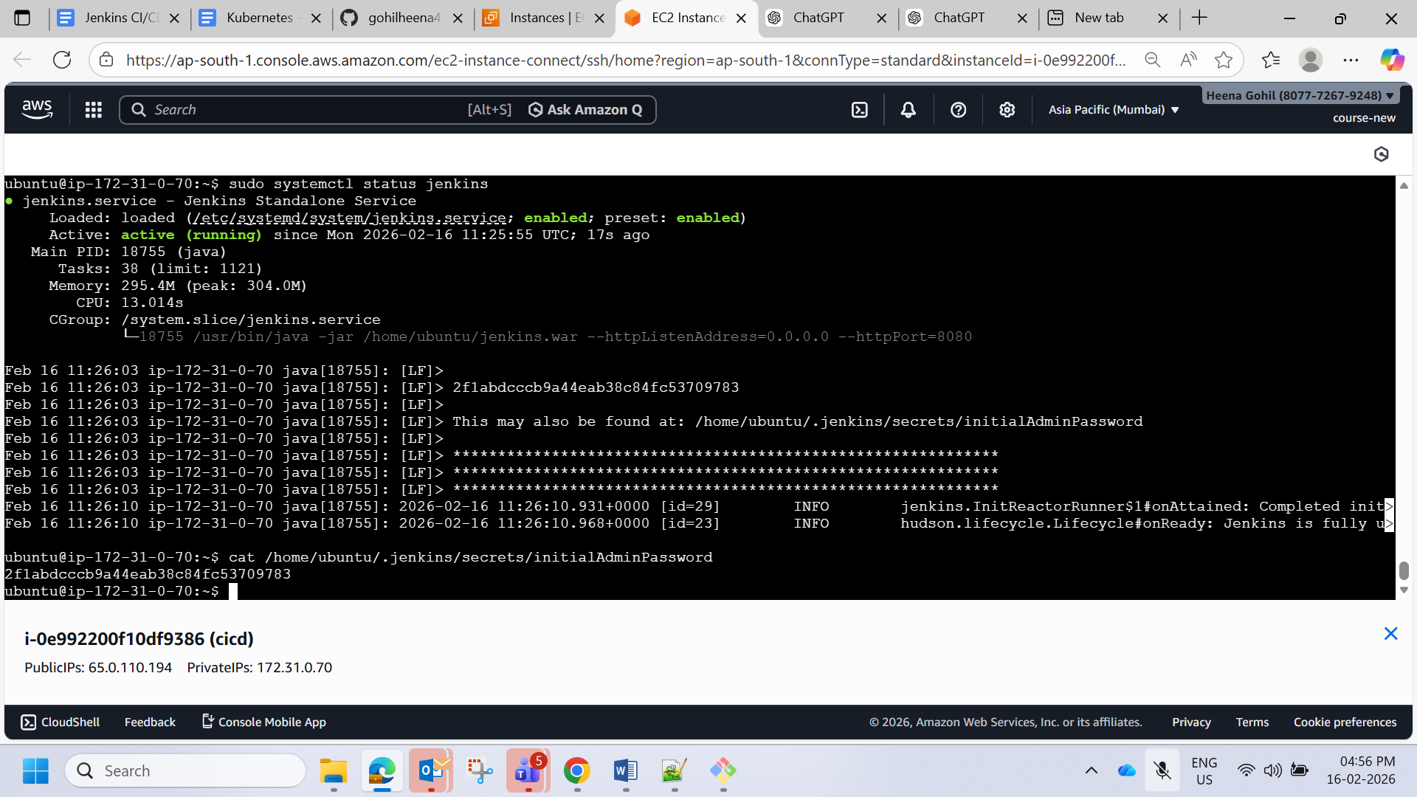

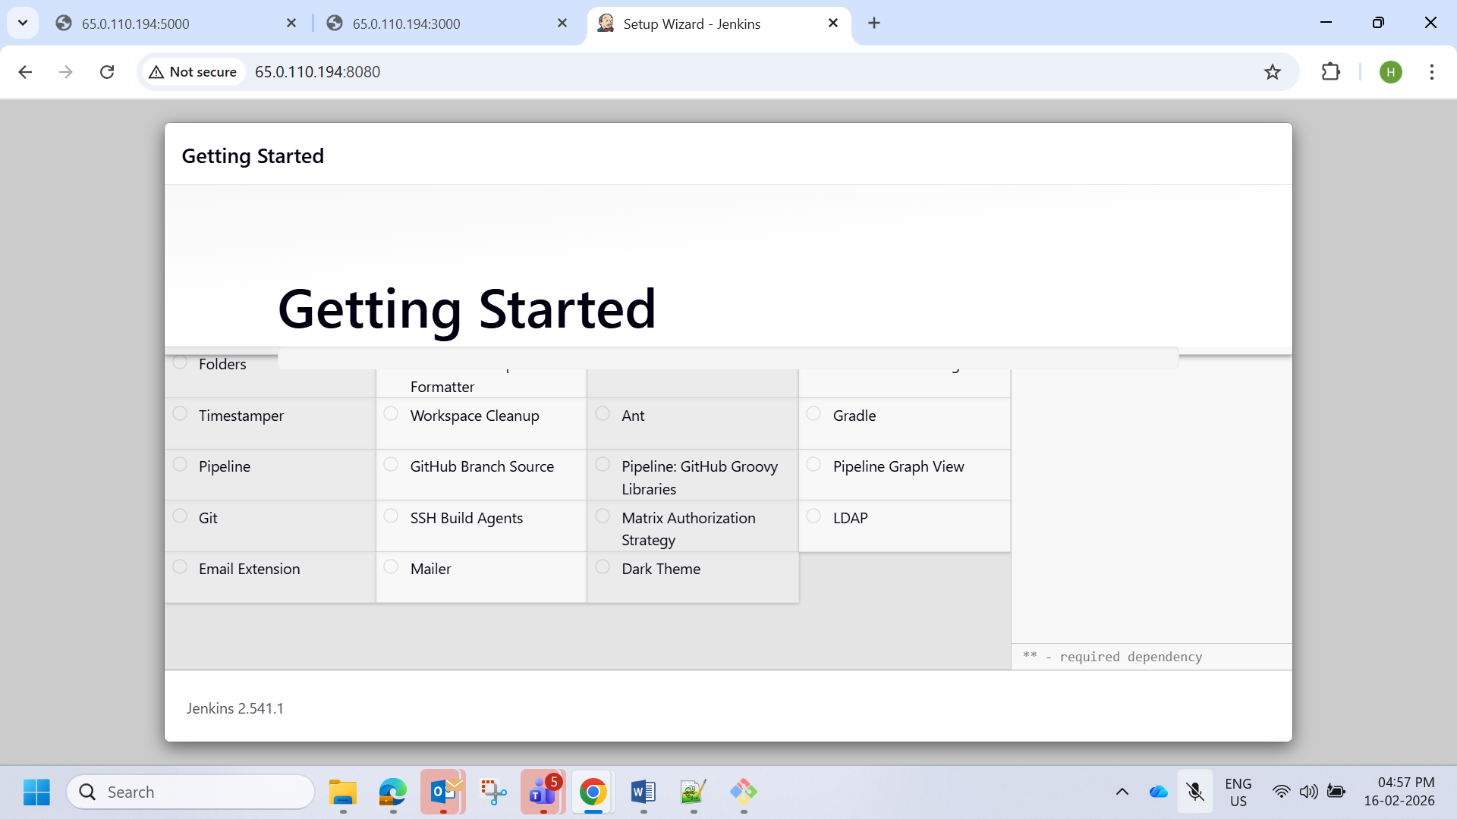

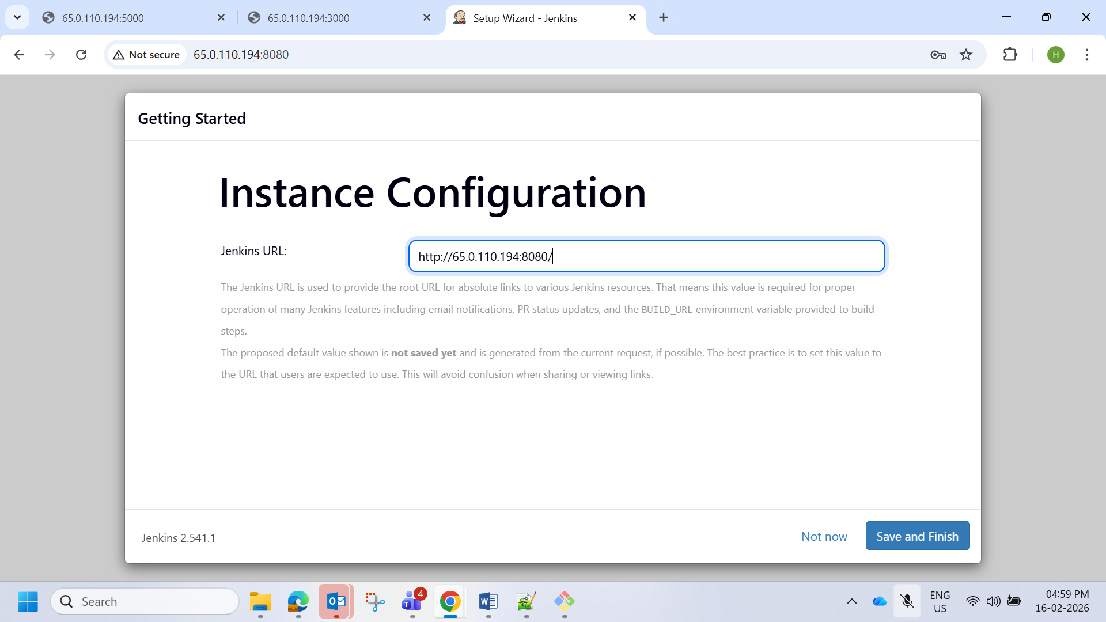

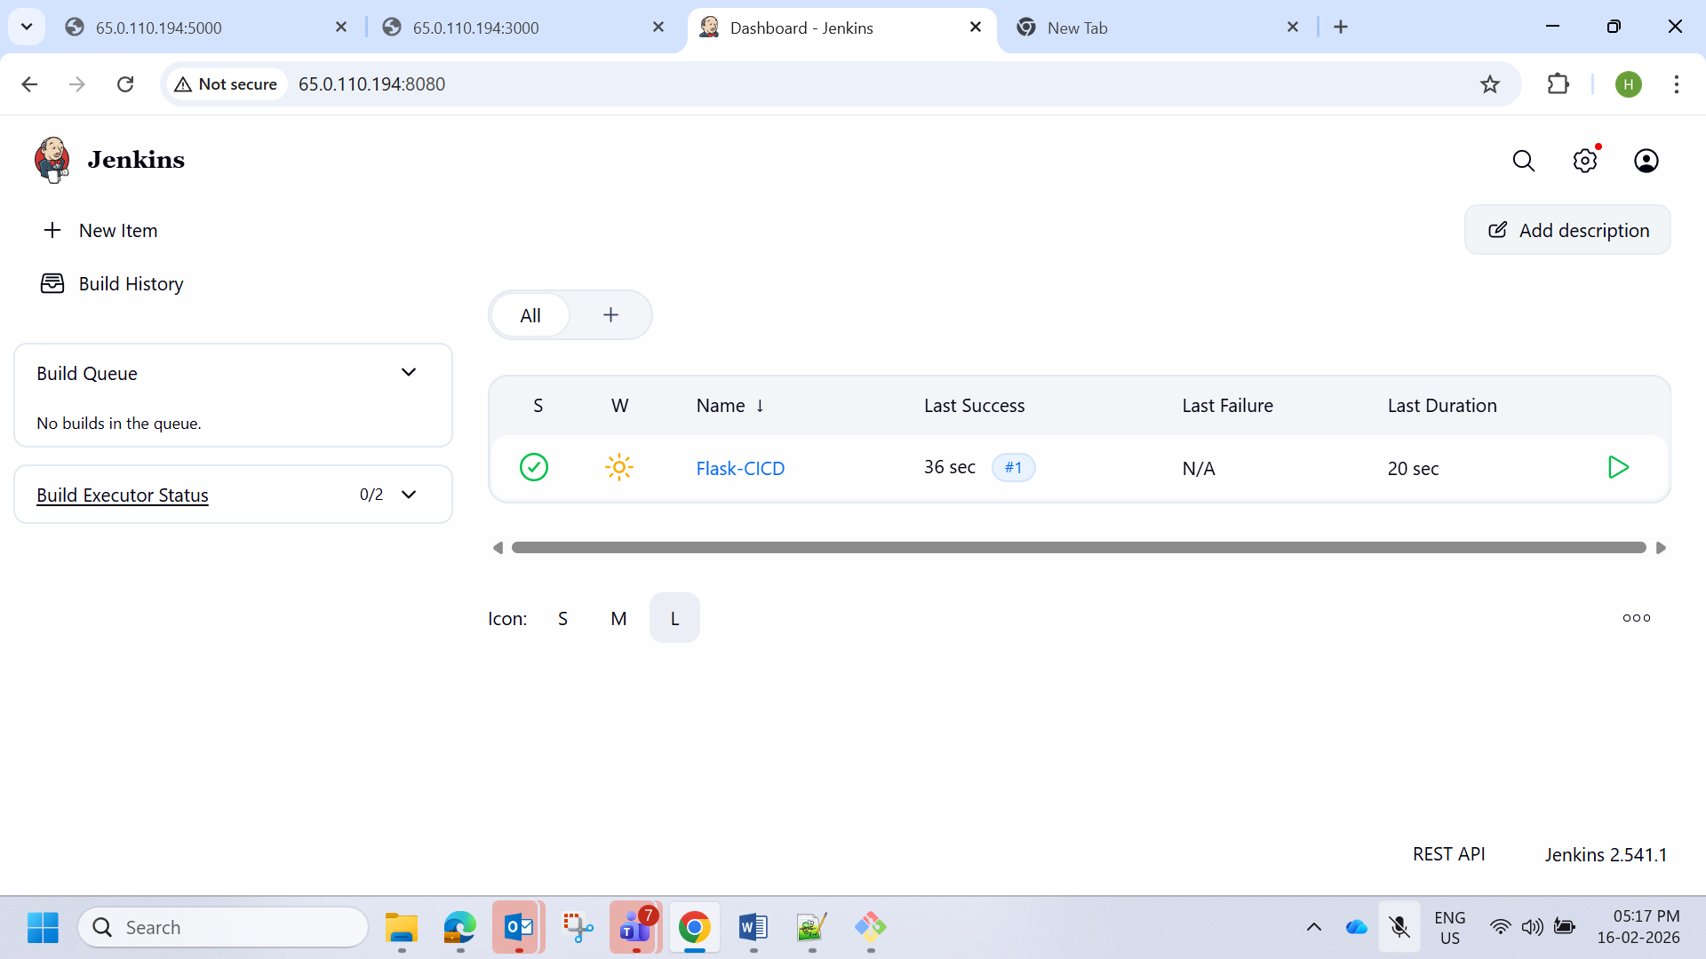

Manually checked

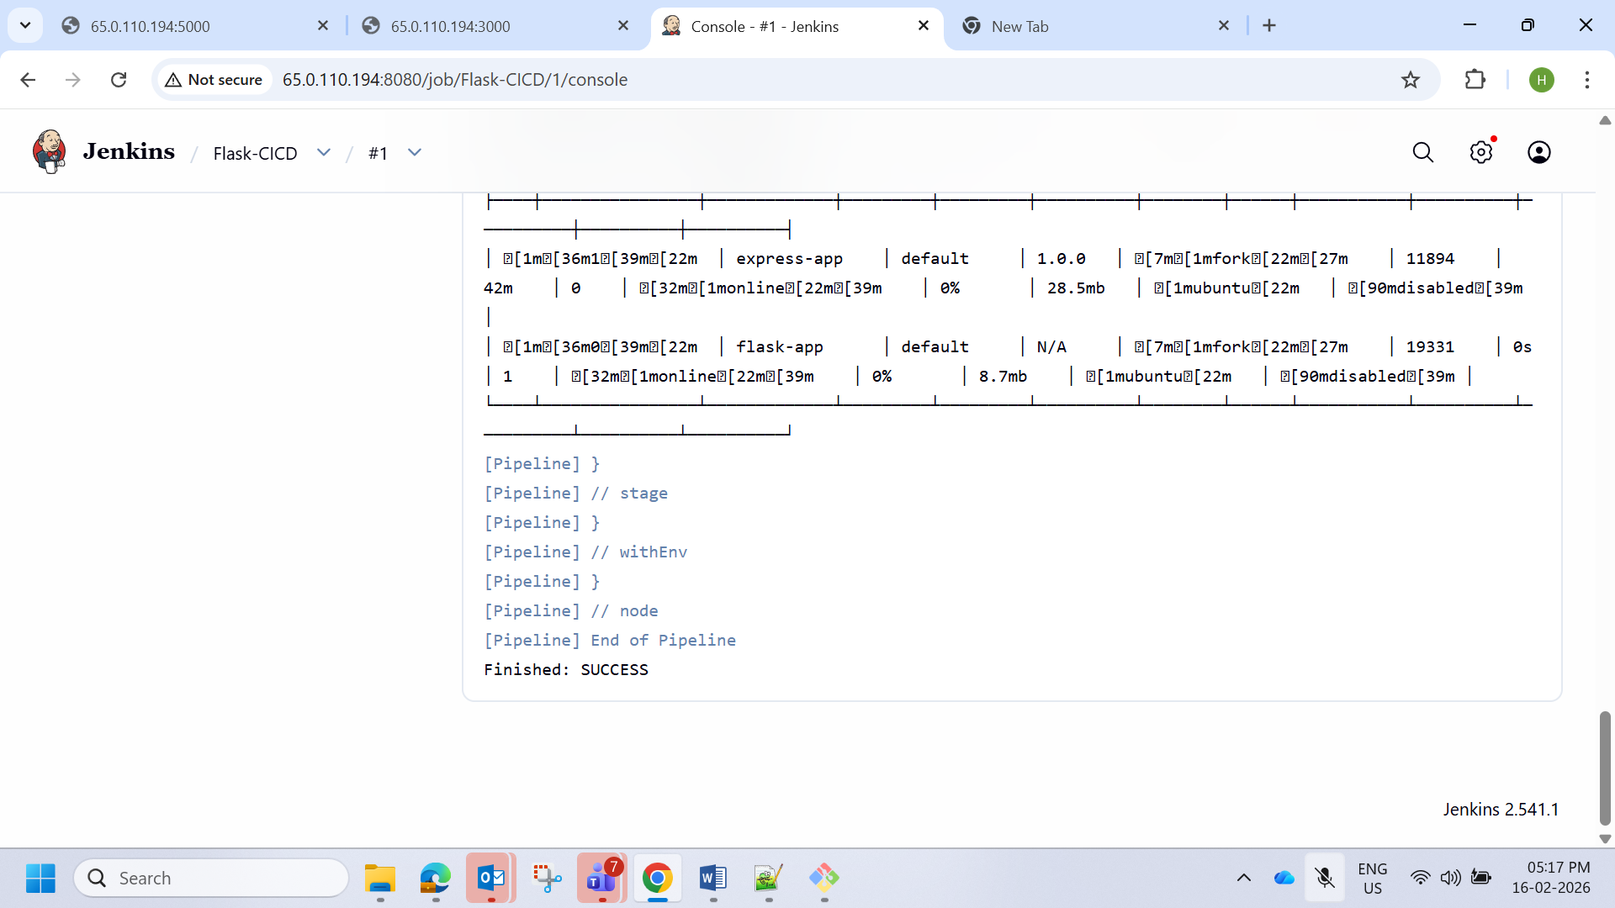express

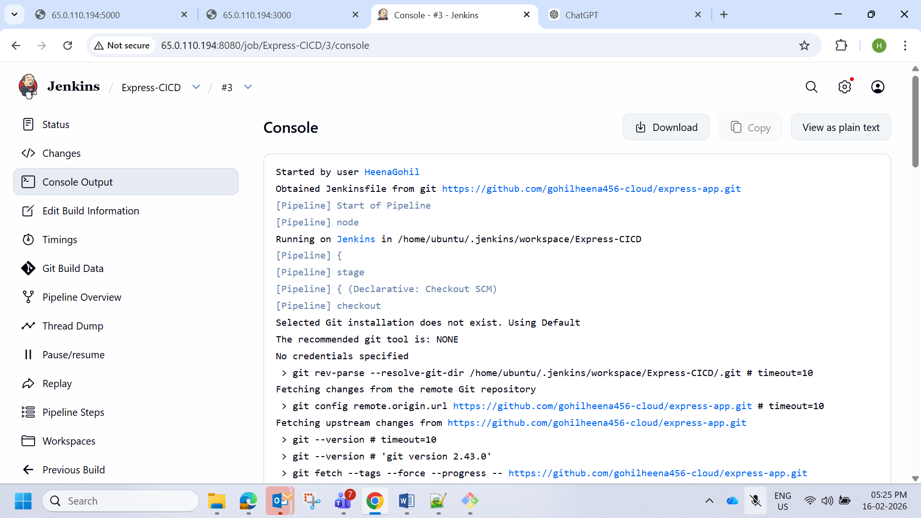

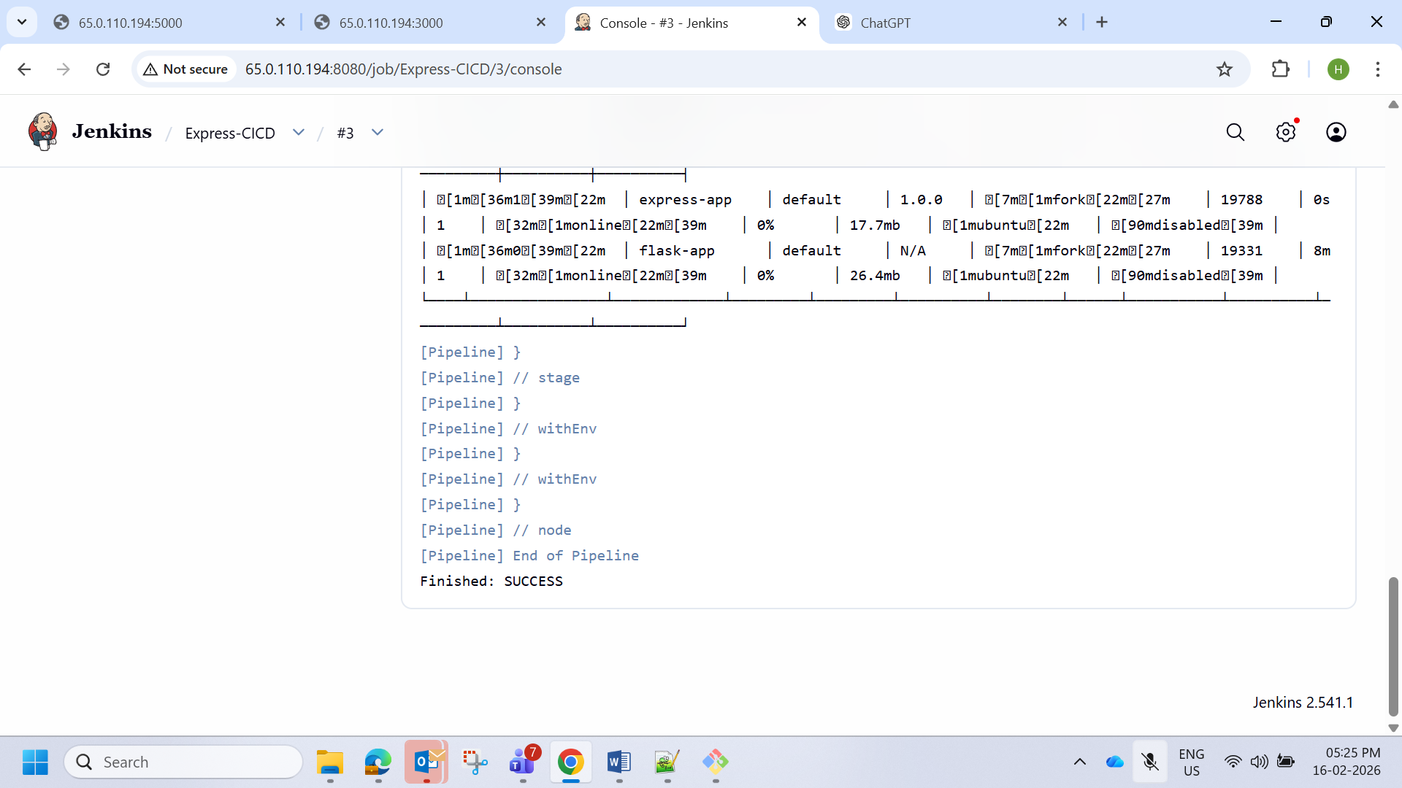

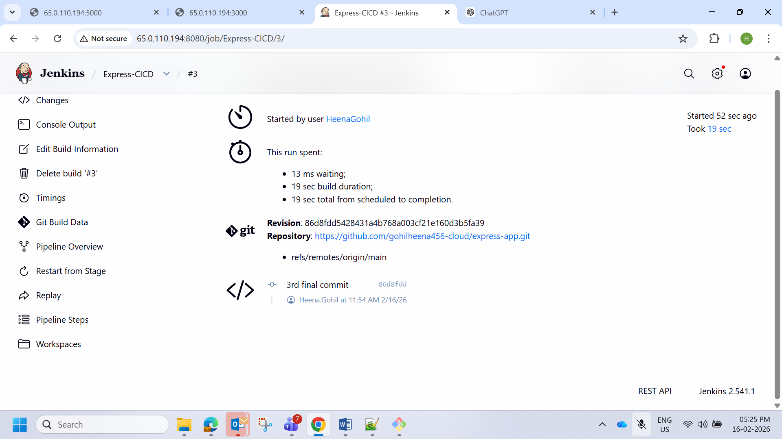

Adding webhook

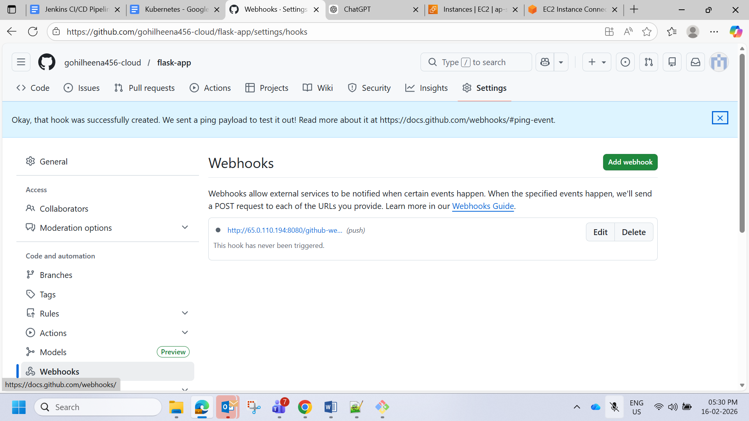

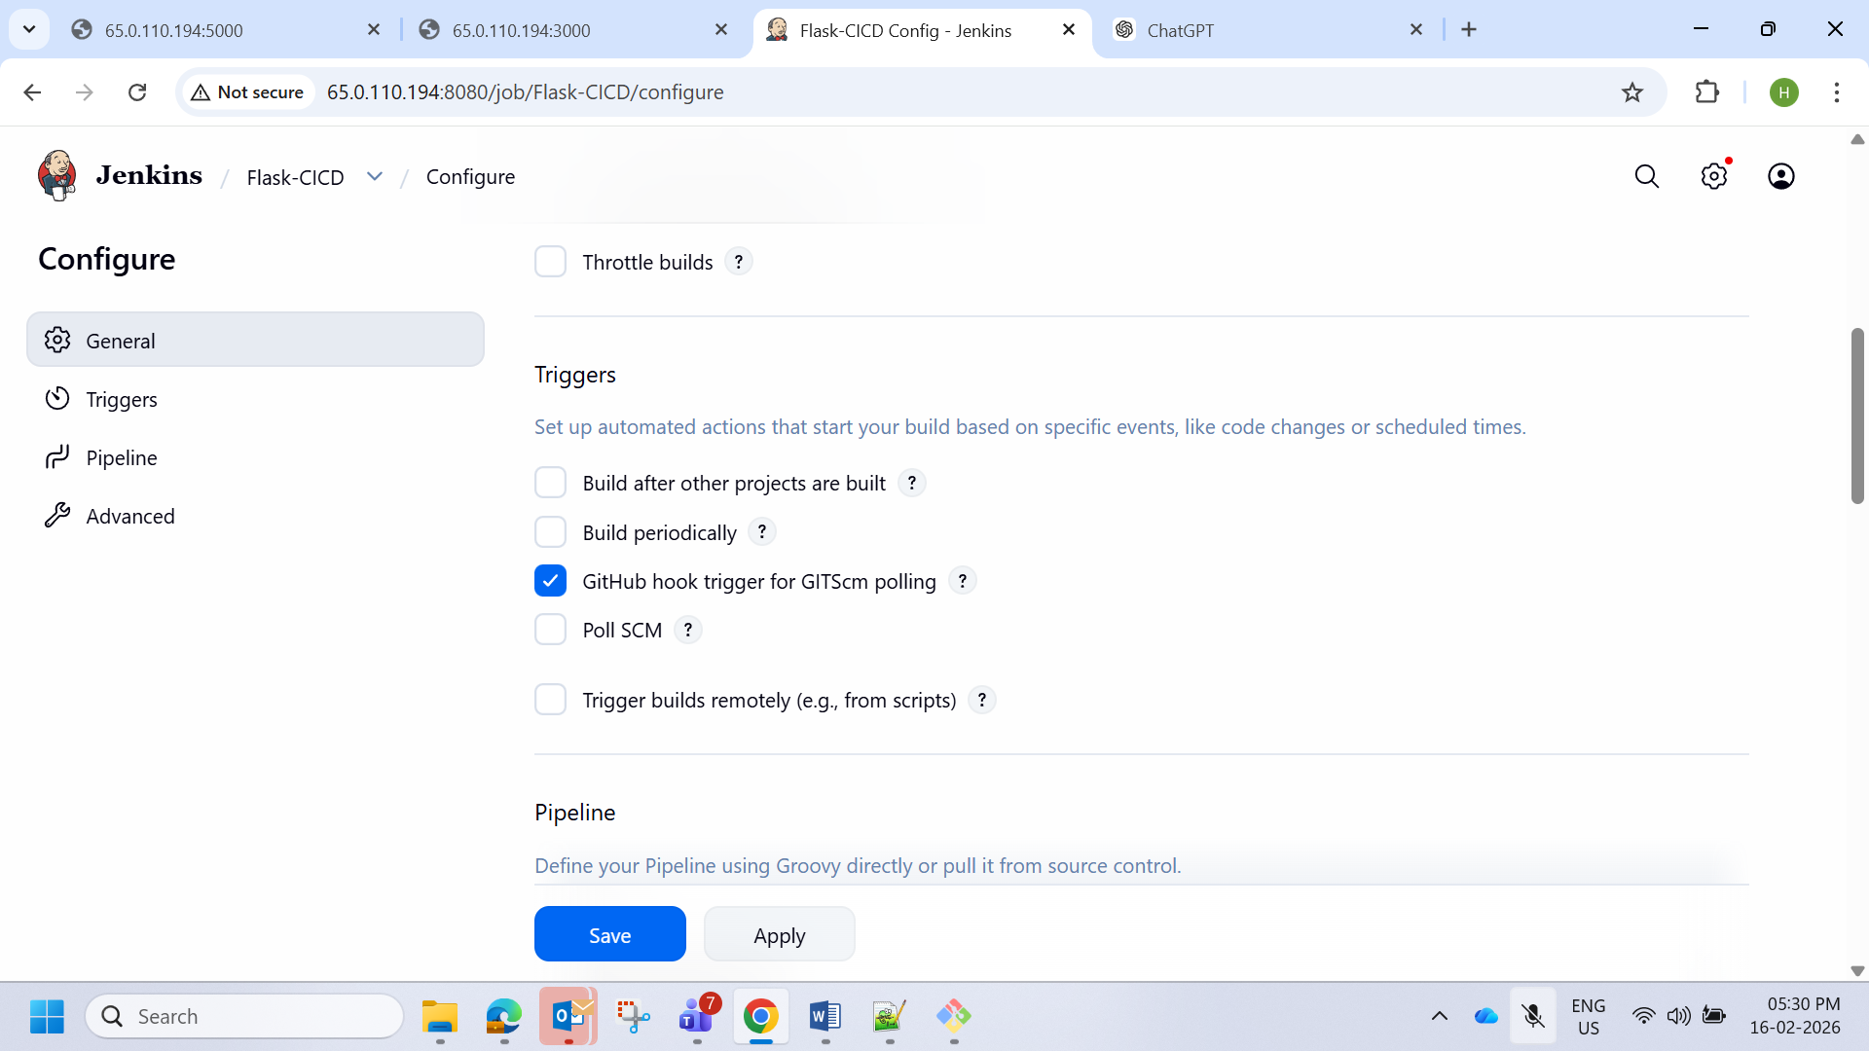

Done some changes in code

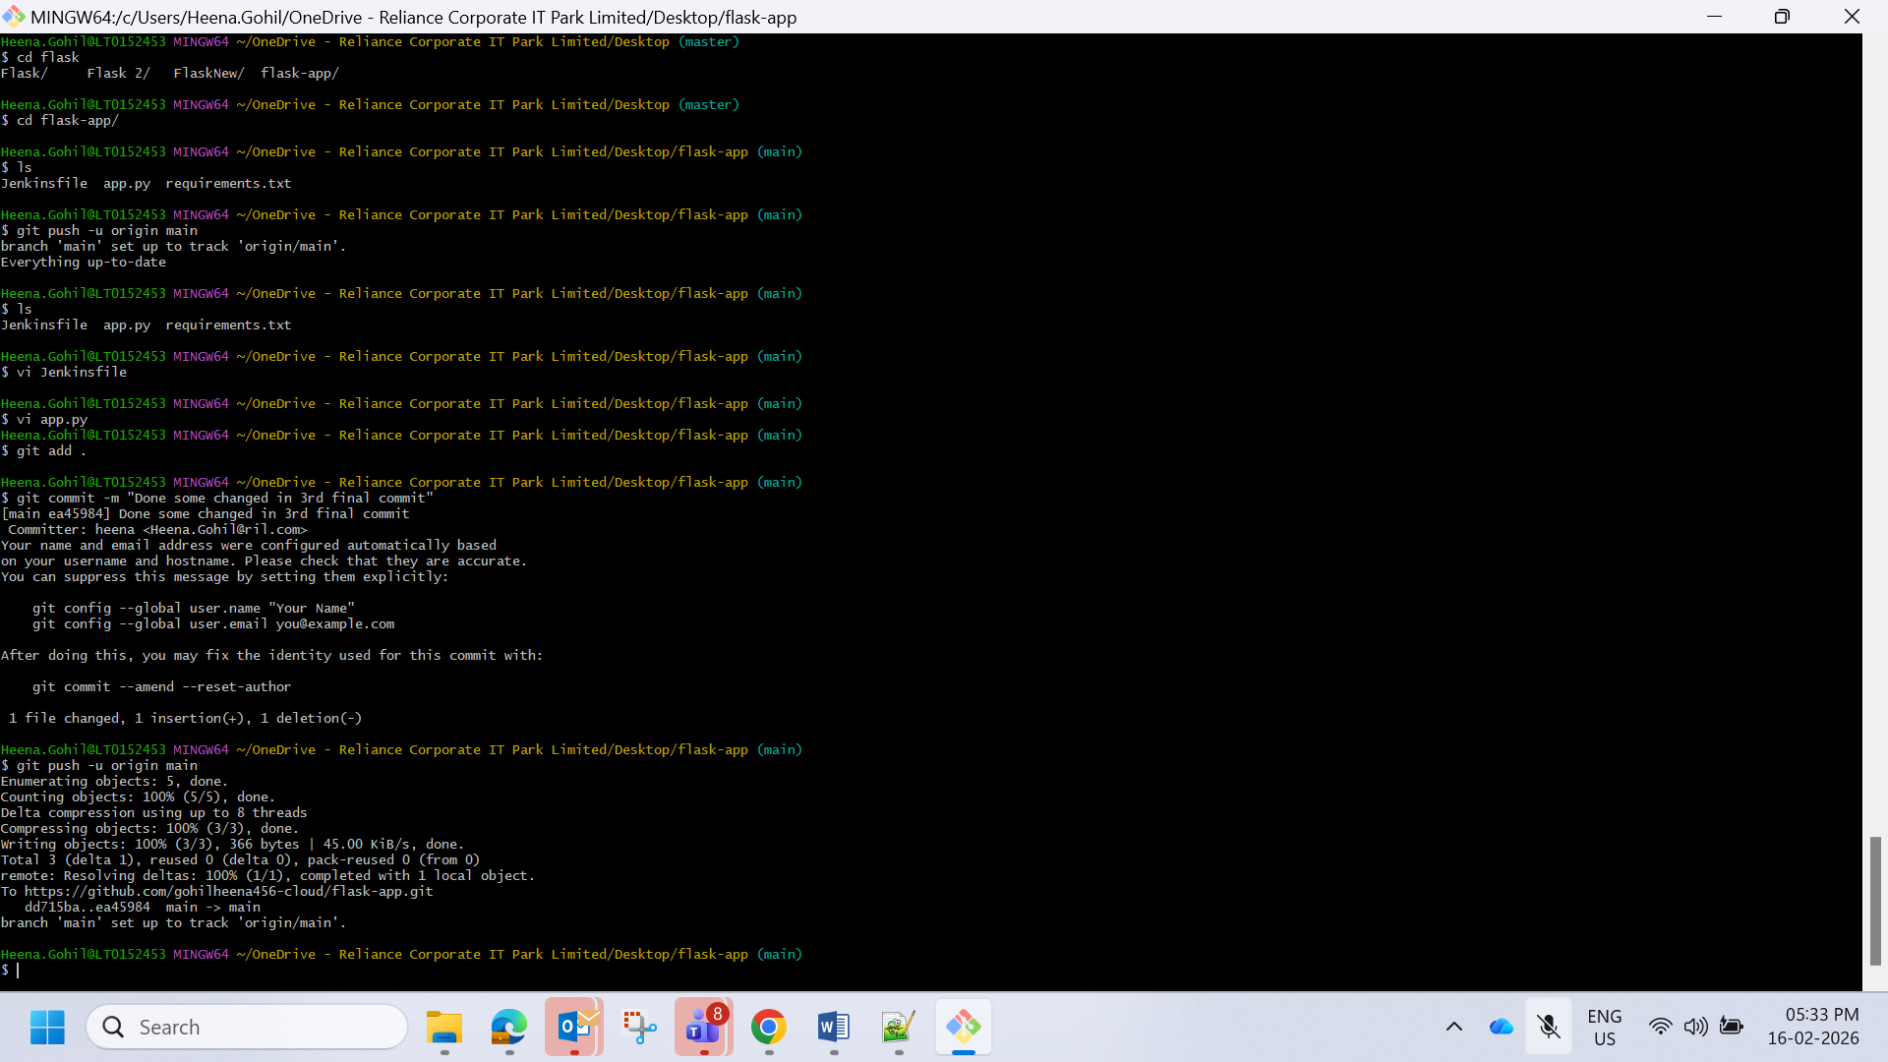

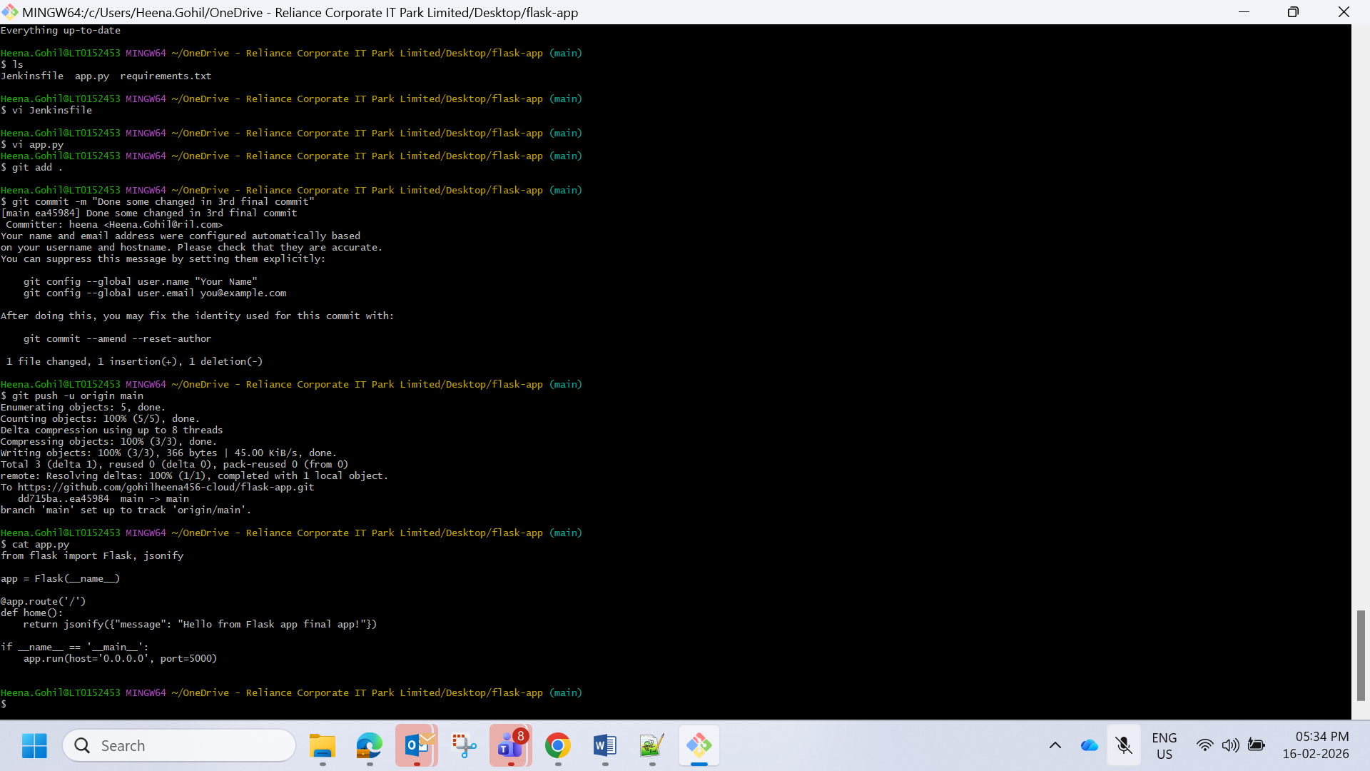

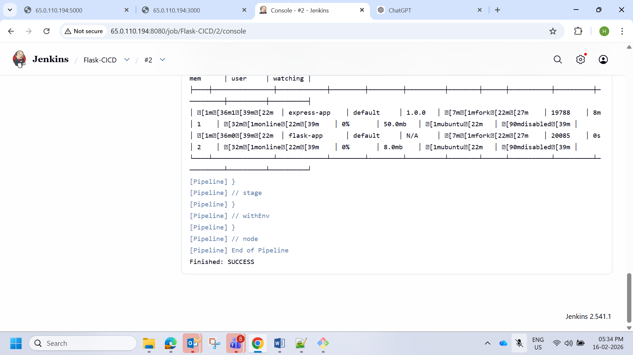

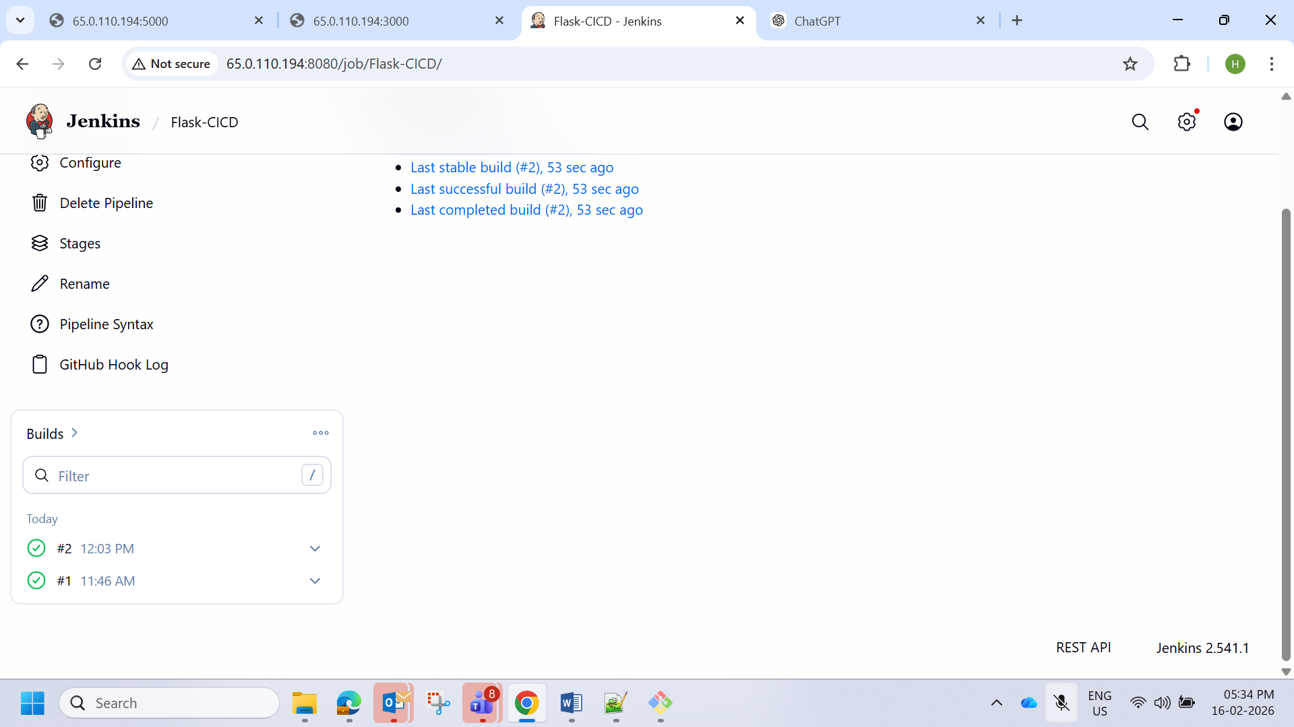

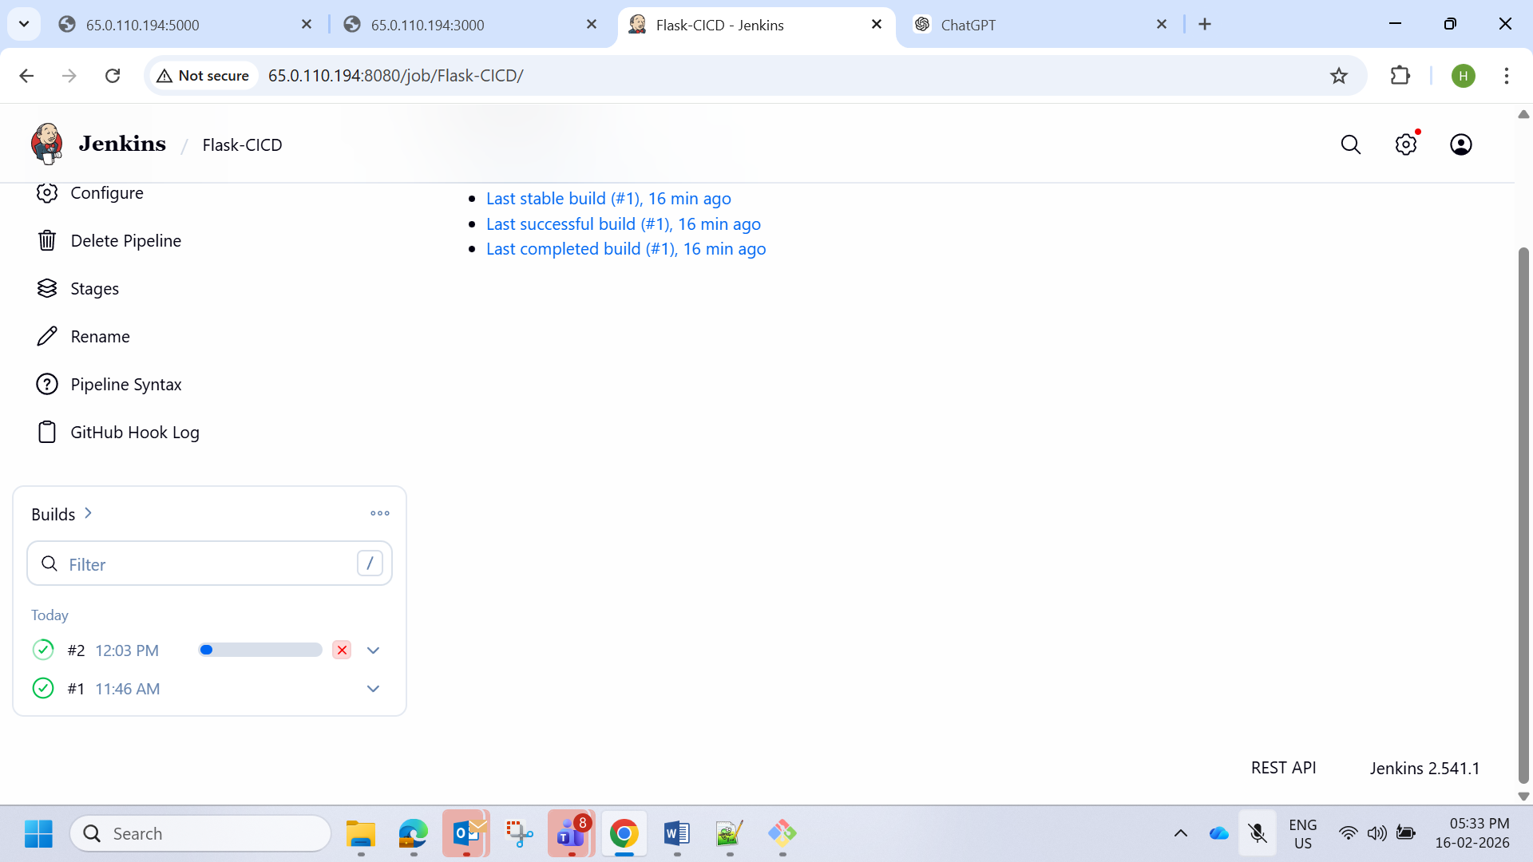

Now for express

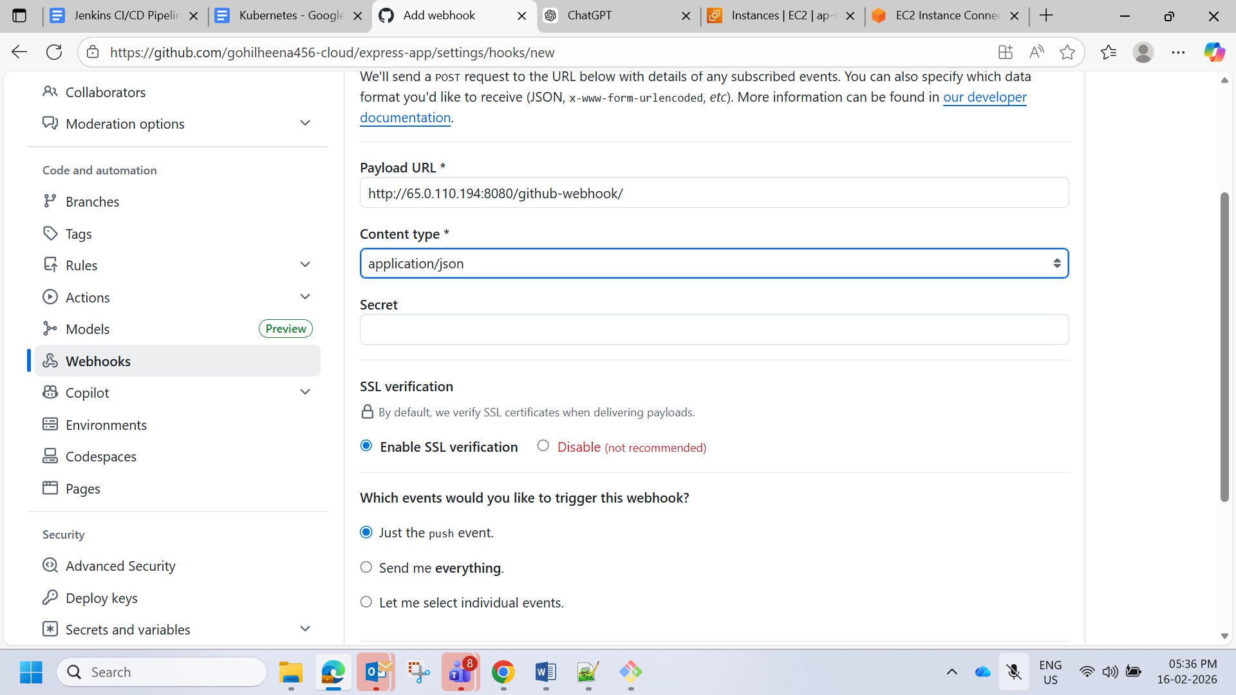

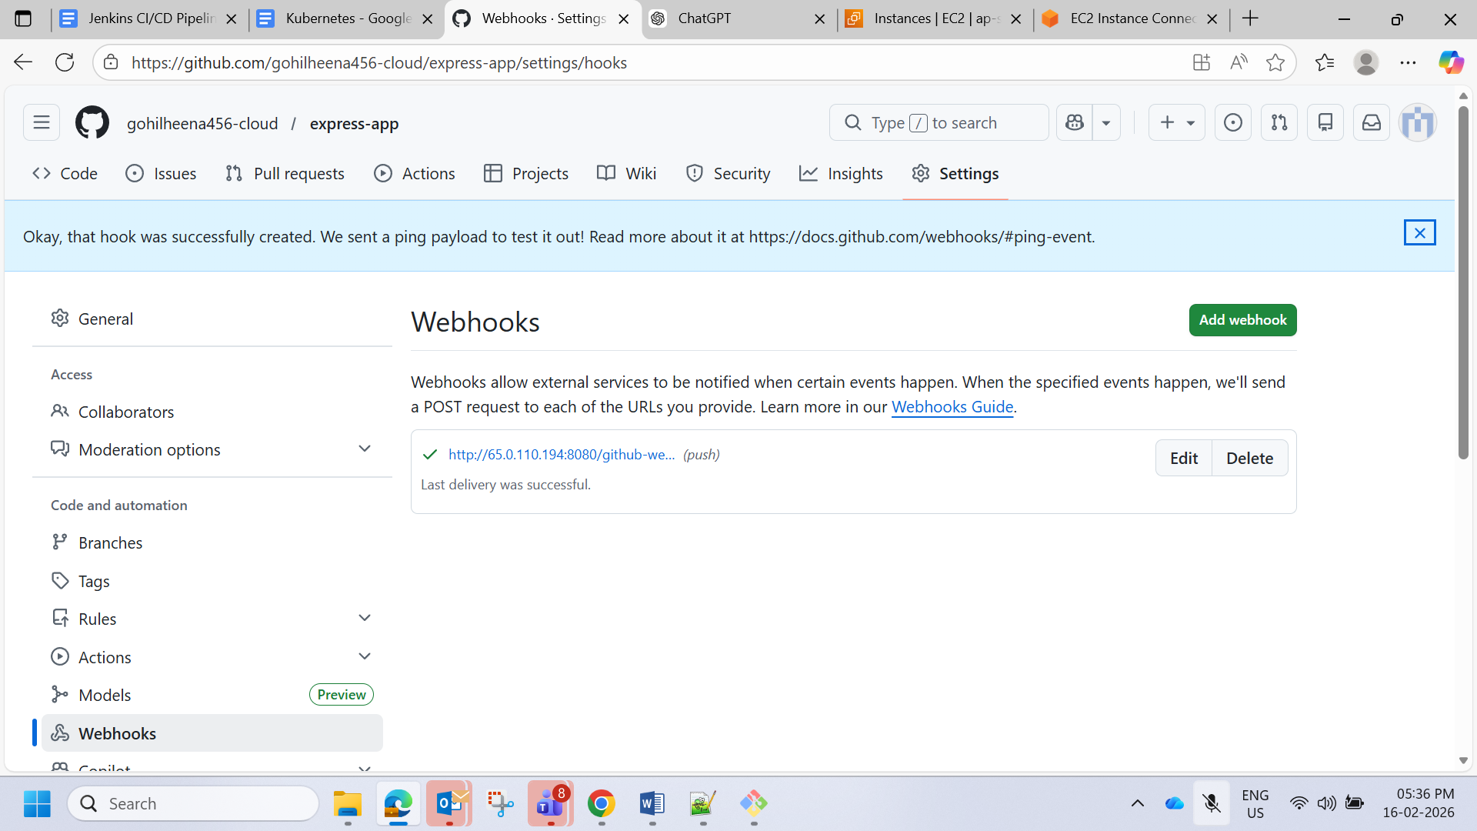

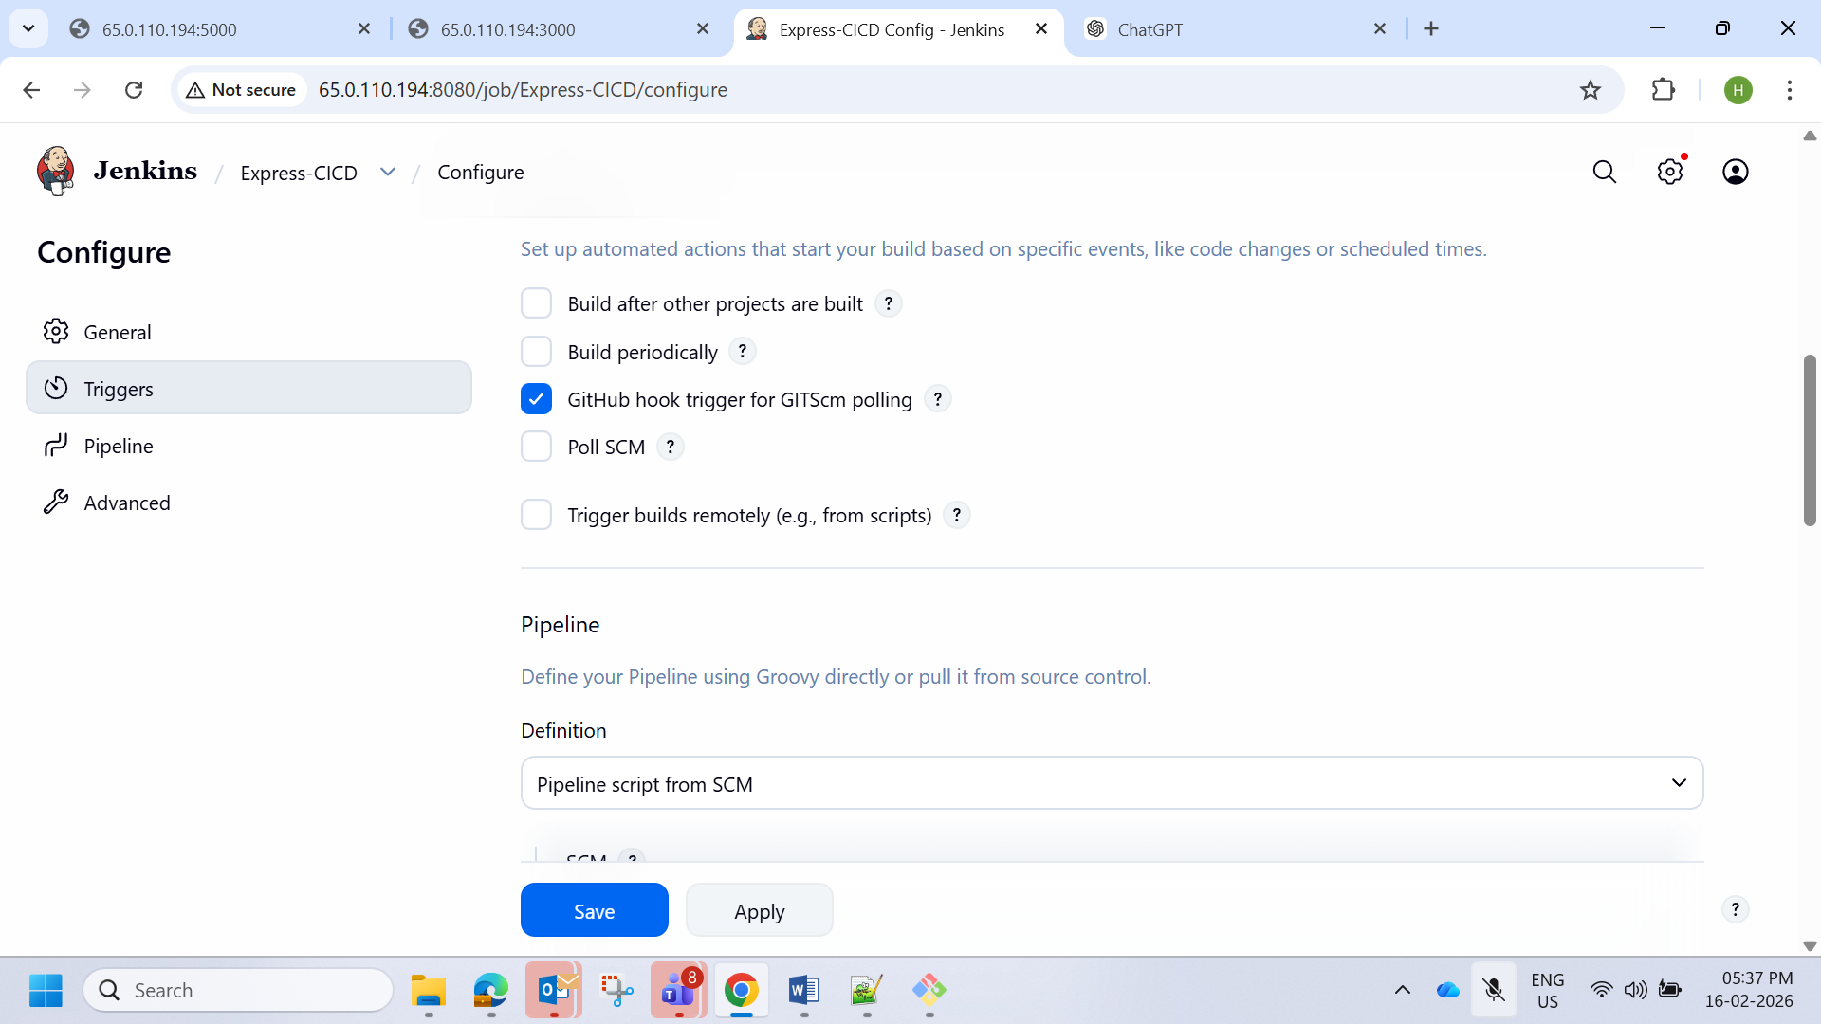

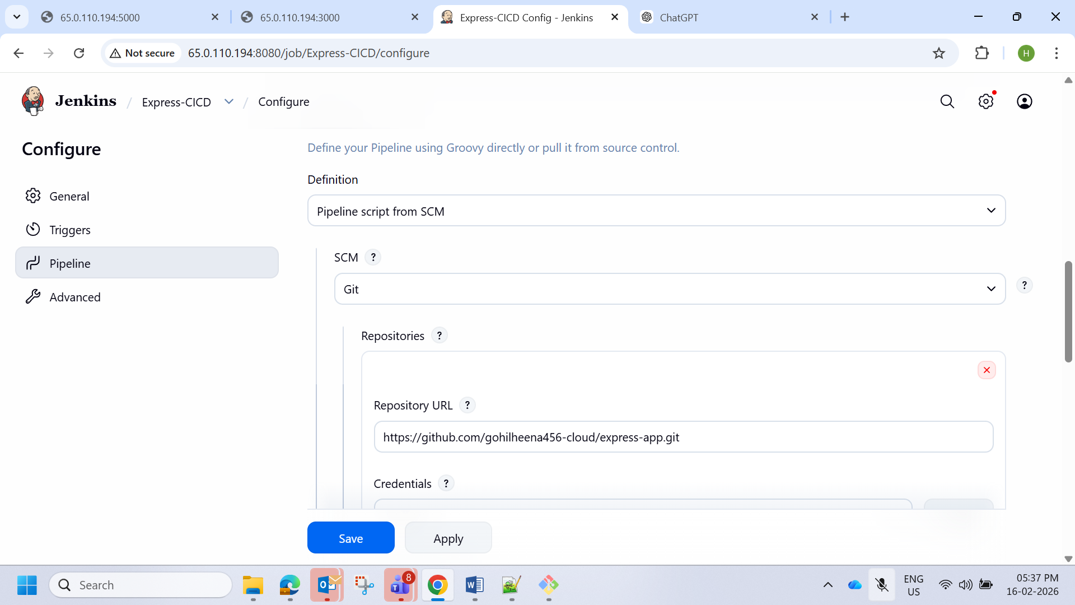

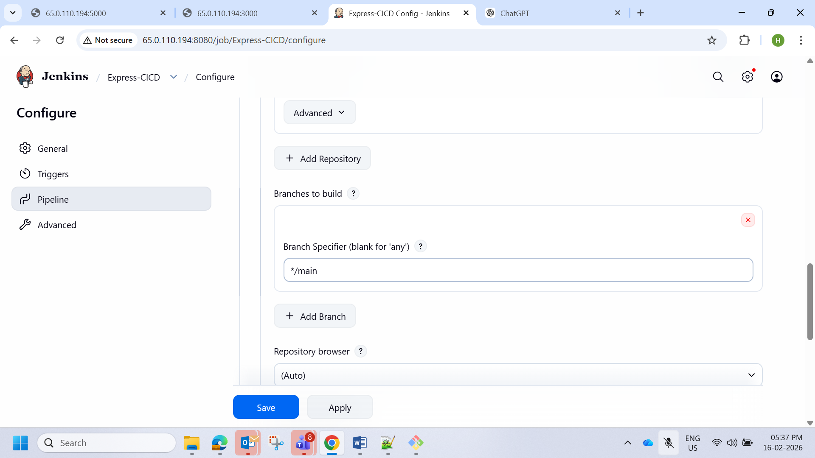

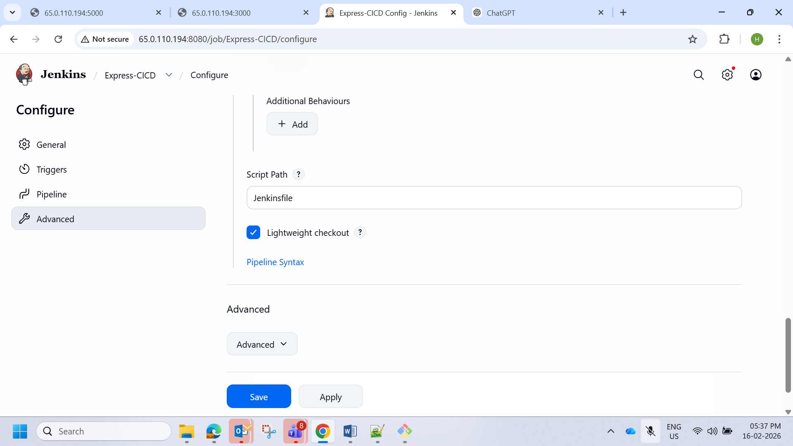

Doing changes in app file

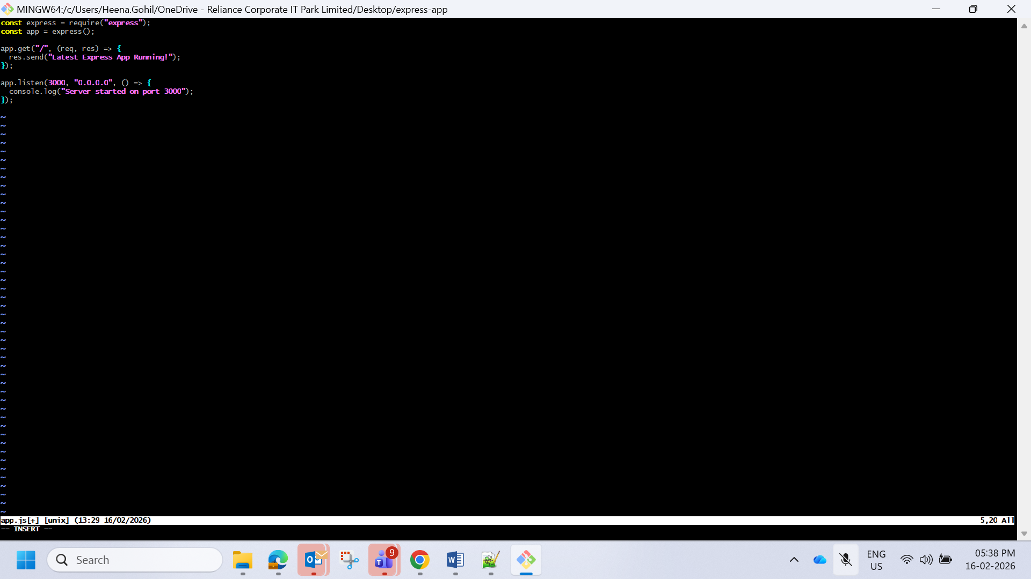

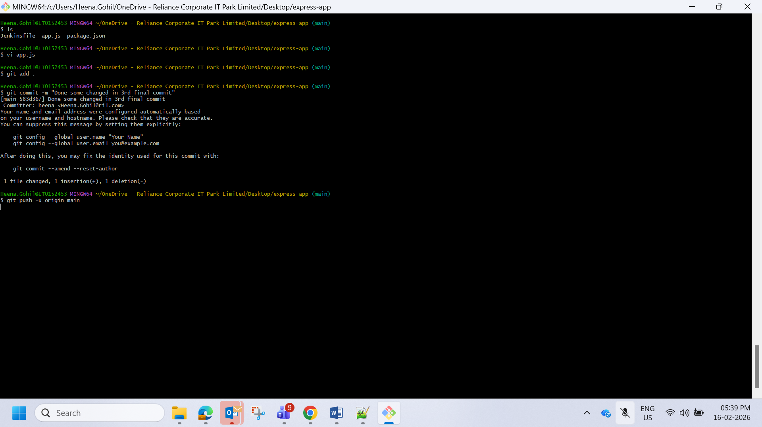

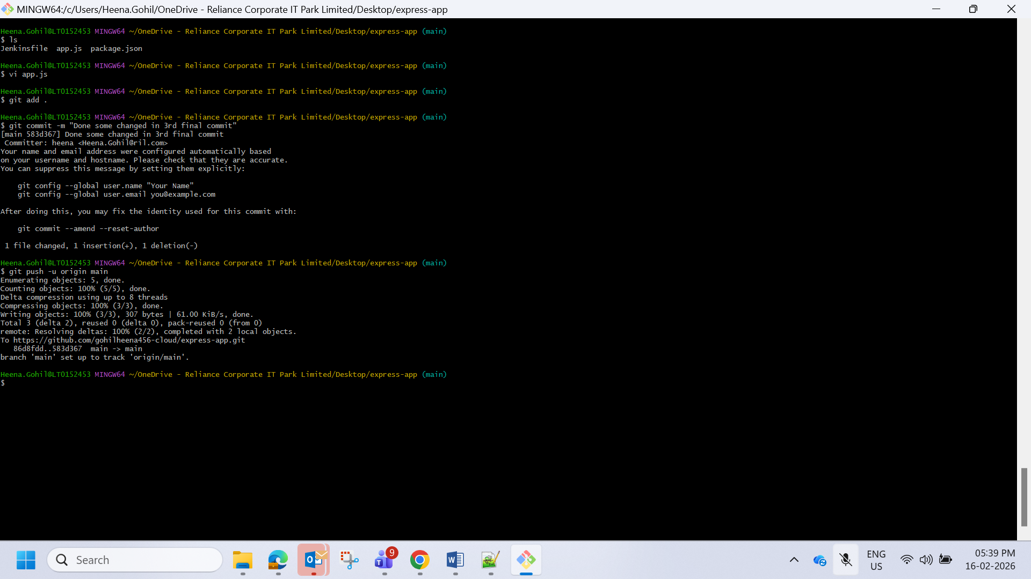

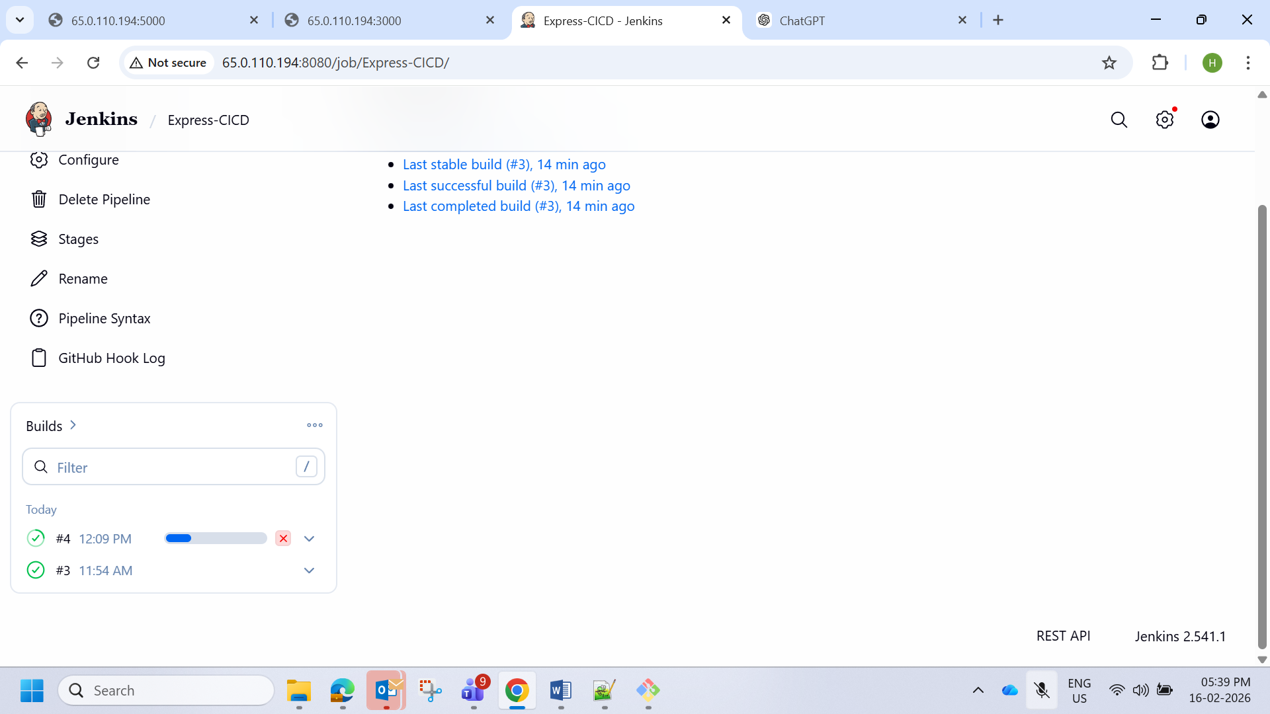

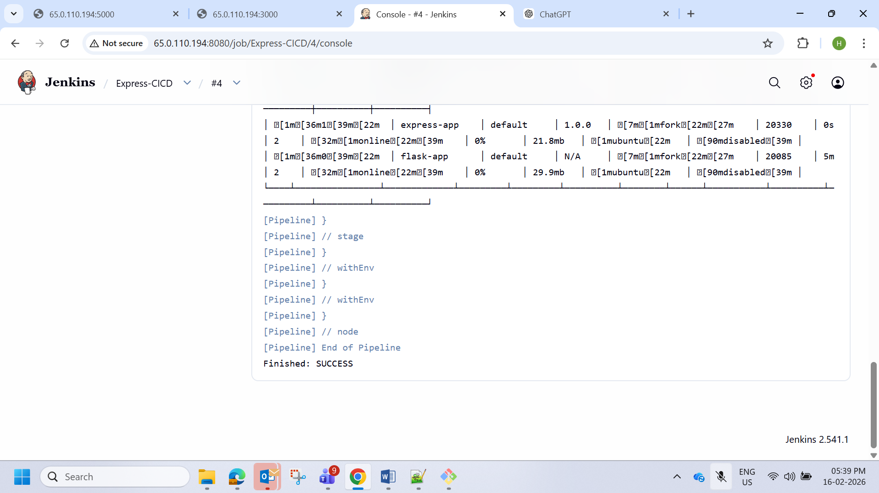

Success

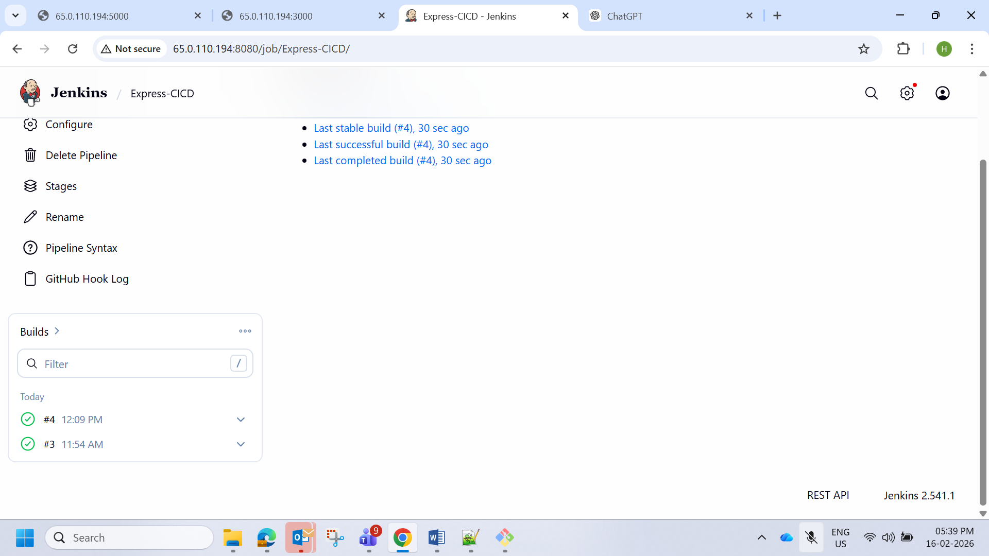

### **Submission Requirements**

1. A link to the GitHub repositories for Flask and Express.
2. A document (README.md) describing the deployment process and CI/CD pipeline setup.
3. Screenshots of:
   * The running EC2 instance with Flask and Express accessible.
   * Jenkins pipeline execution logs showing successful deployment.

Github links

<https://github.com/gohilheena456-cloud/flask-app.git>

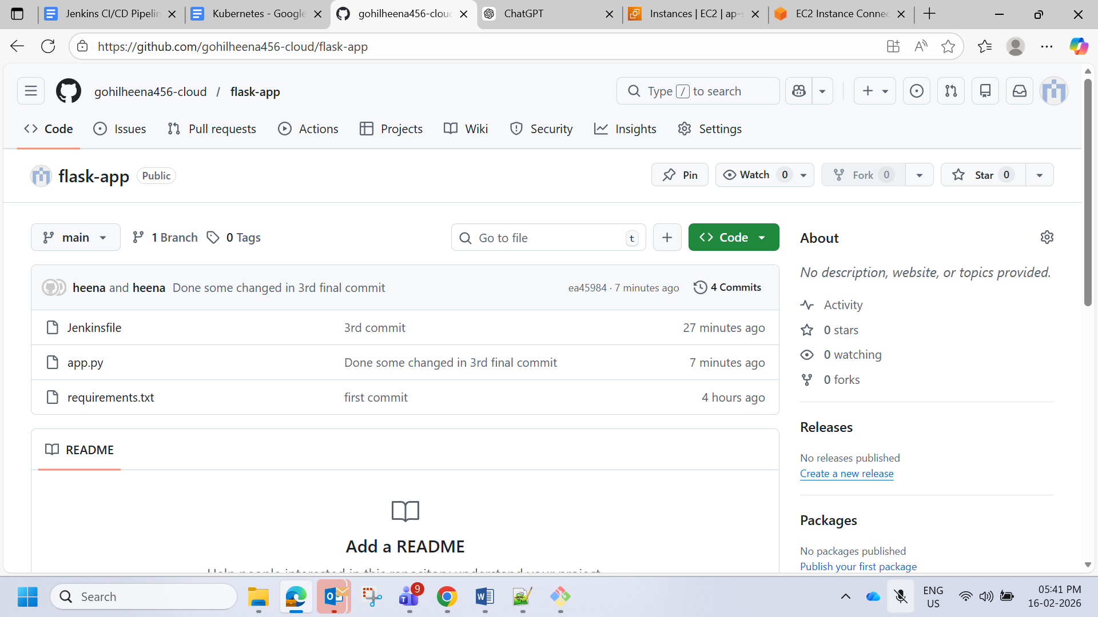

<https://github.com/gohilheena456-cloud/express-app.git>

